Make a healthy human

Roll the dice. Draw what each number tells you to give your human in each circle.

1
2
3
4
5
6

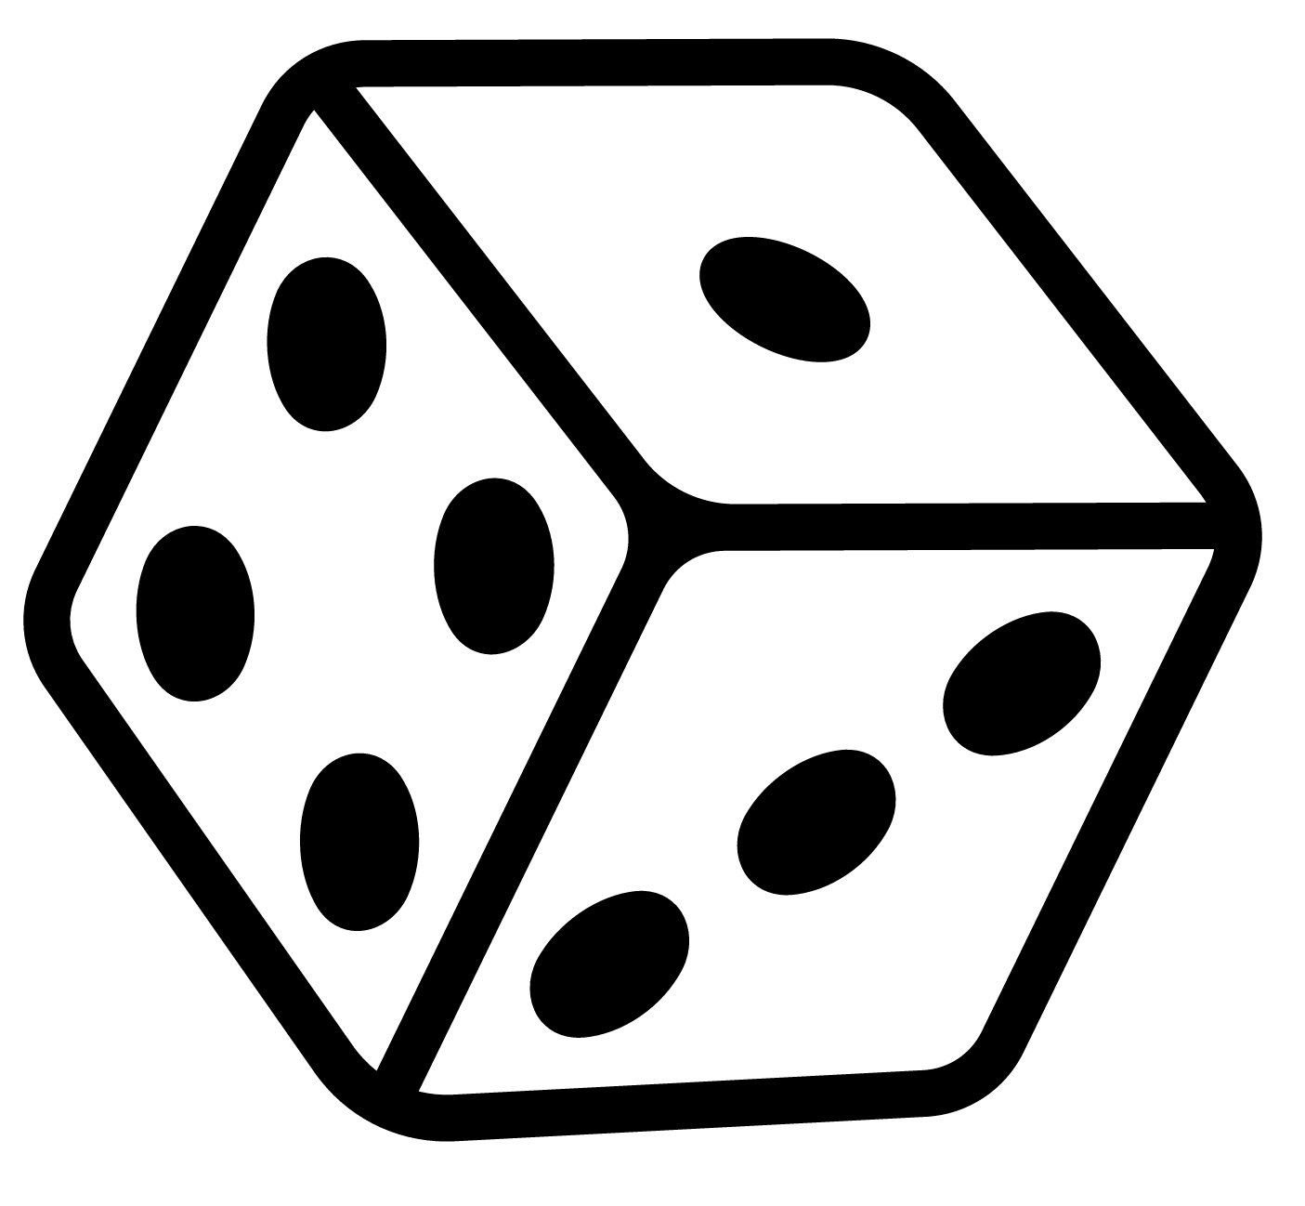

1 | Your human is thirsty! Give them a drink.
2 | Your human needs more vegetables. Draw a vegetable for them.
3 | Your human needs some protein. Draw a protein food for them.
4 | Your human needs some starchy food. Draw a starchy food for them.
5 | Your human needs some dairy food or (a dairy alternative). Draw a dairy food (or alternative) for them.
6 | Your human needs to do some activity. Draw an activity for them.

When your human has everything they need, you can colour them in!

