Food commodities: Red meat and poultry
- Food is sourced, processed, and sold in different ways
- Food production and processing ensures that food is edible and safe

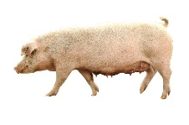
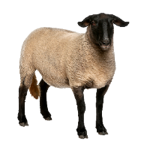
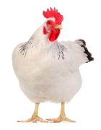
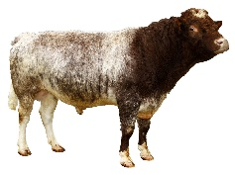
Livestock farming
- Cattle, pigs, sheep and chickens have been farmed for many years.
- In the UK, meat comes mainly from: cattle (beef), pigs (pork), sheep (lamb) and poultry (chicken).

- There are more than 10 million cattle, 5 million pigs, over 33 million sheep and 182 million livestock birds in the UK.
- Pigs are generally reared by specialist pig farmers, with 40% of pig production being outdoors.
- In the UK, cattle and sheep graze outdoors in the summer; however, many are housed in sheds during the winter to protect them from bad weather.
- Cattle, sheep and pigs wear an eartag so they can be identified. Traceability from the farm is important when producing food.
- The health and welfare of all animals is a top priority for livestock farmers, as well as sustainability.
- Farmers manage and maintain the countryside including hedgerows and field boundaries, which are habitat for wildlife.
- Grazing cattle and sheep play an important part in managing our natural grasslands.
- Chickens farmed for meat are called broiler chickens and in 2020 over 100 million broiler eggs were laid.

Tasks
- Research the farm to fork journey of beef, lamb, pork or chicken in the UK. Draw a poster to show your findings.
- Identify two recipes that contain two different cuts of meat and compare the different preparation and cooking methods.

Meat and poultry nutrition
Meat and poultry are good sources of protein as well as different vitamins and minerals. Poultry like chicken provides B vitamins, phosphorus and selenium and can be low in fat if you choose chicken breast without skin.
Red meats like beef, lamb and pork provide B vitamins, phosphorus, potassium and zinc. Meat is one of the main sources of vitamin B12 in the diet. Beef is a source of iron and pork a source of selenium. Red meat can be high in saturated fat, but you can reduce this by choosing lean cuts and cutting off any extra fat.

Red Tractor assurance standards encompass food safety, animal welfare, environmental protection,
and traceability.
Protected Geographical Indication (PGI) products must be produced, processed, or prepared within the geographical area.

Buying meat and food labels
Meat is available to purchase from butchers and supermarkets.
Preparing & cooking meat
- Food preservation is important to increase the shelf life of products including meat. Shelf life depends on water; acidity; hygienic handling; methods of preservation.
- Meat can be tenderised by physical action, enzymes or acids and marinades.
- Meat changes colour during food preparation when the pigment myoglobin changes.
There are three main methods of heat transfer normally used for cooking meat - convection; conduction; radiation.
- Convection is where currents of hot air or hot liquid transfer the heat energy to the food, e.g., roasting.
- Conduction is where heat is transferred through solid objects by the vibration of heated molecules, e.g., stir frying.
- Radiation is where heat is transferred from a heat source in the form of rays which travel quickly in straight lines, e.g., grilling.

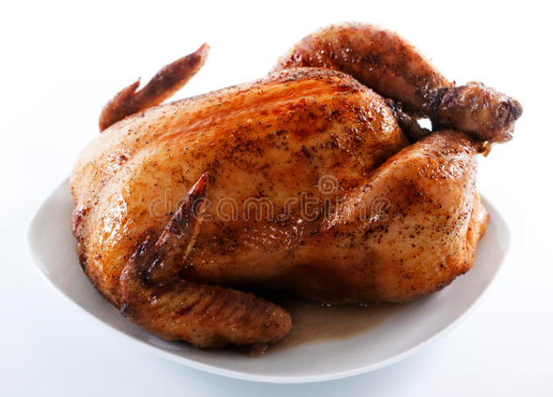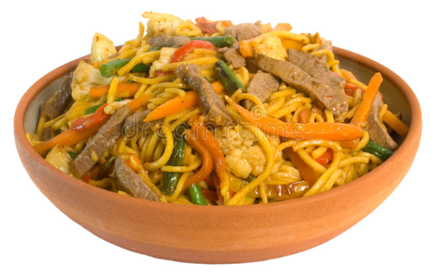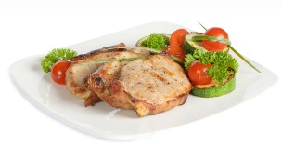

Key terms
Muscle fibres: Are made up of cells which contain proteins actin and myosin.
Offal: Collective name for the internal parts of the animal that we eat.
Joint: A large piece of meat that is cooked in one piece.
Tenderising: To apply a process or substance that breaks down the connective tissue found in meat.
Preservation: The process of extending the shelf-life of a food product by inhibiting the growth of micro-organisms.
Curing: A preservation process that removes moisture from meat.
Protein: A component of food that is made up of amino acids.
Iron: A mineral element that is essential in the diet to make red blood cells that carry oxygen to the tissues.
Traceability: A system to track food through the stages of production, processing and distribution.

Meat types and cuts
- Meat is available to buy in the form of cuts, joints or mince. It is also available ready prepared, e.g., sausages, ham, burgers.
- The variety of cuts of meat available to the consumer provide choice, are convenient to prepare, simple to store and easy to cook.
- Different cuts of meat have different characteristics, e.g., energy and nutrients, composition, weight, size and appearance.
- Because of where the cut of meat comes from on the animal, different cuts require different cooking methods, e.g., slow (casserole), quicker (stir-fry).
- To add choice and variety, pork is cured e.g., bacon, and offal is also available to be used in a range of popular dishes, e.g., liver.
- Types of poultry meat include chicken, turkey, duck, goose and game birds e.g., pheasants and partridges.

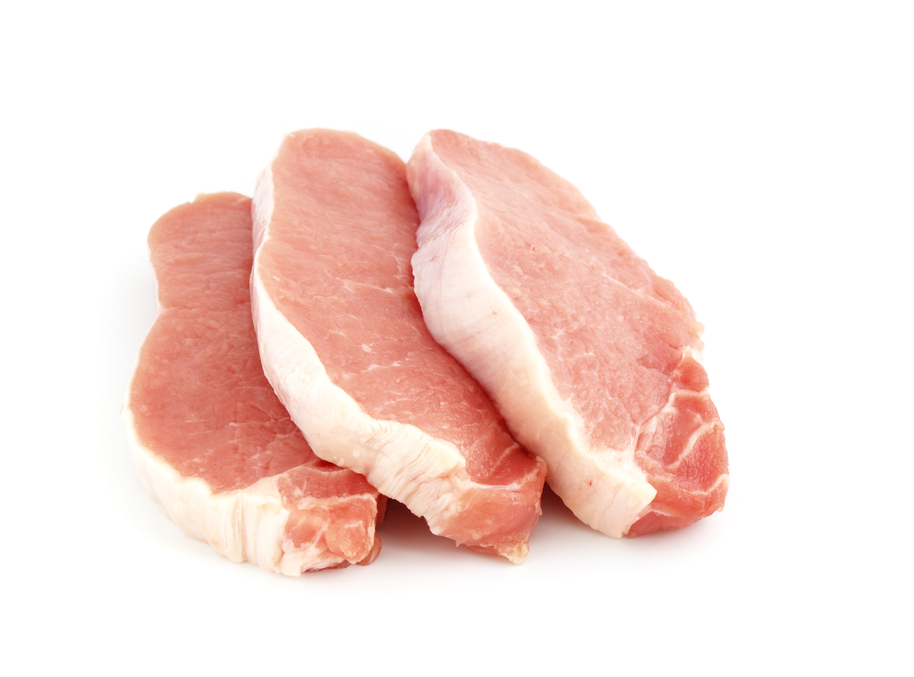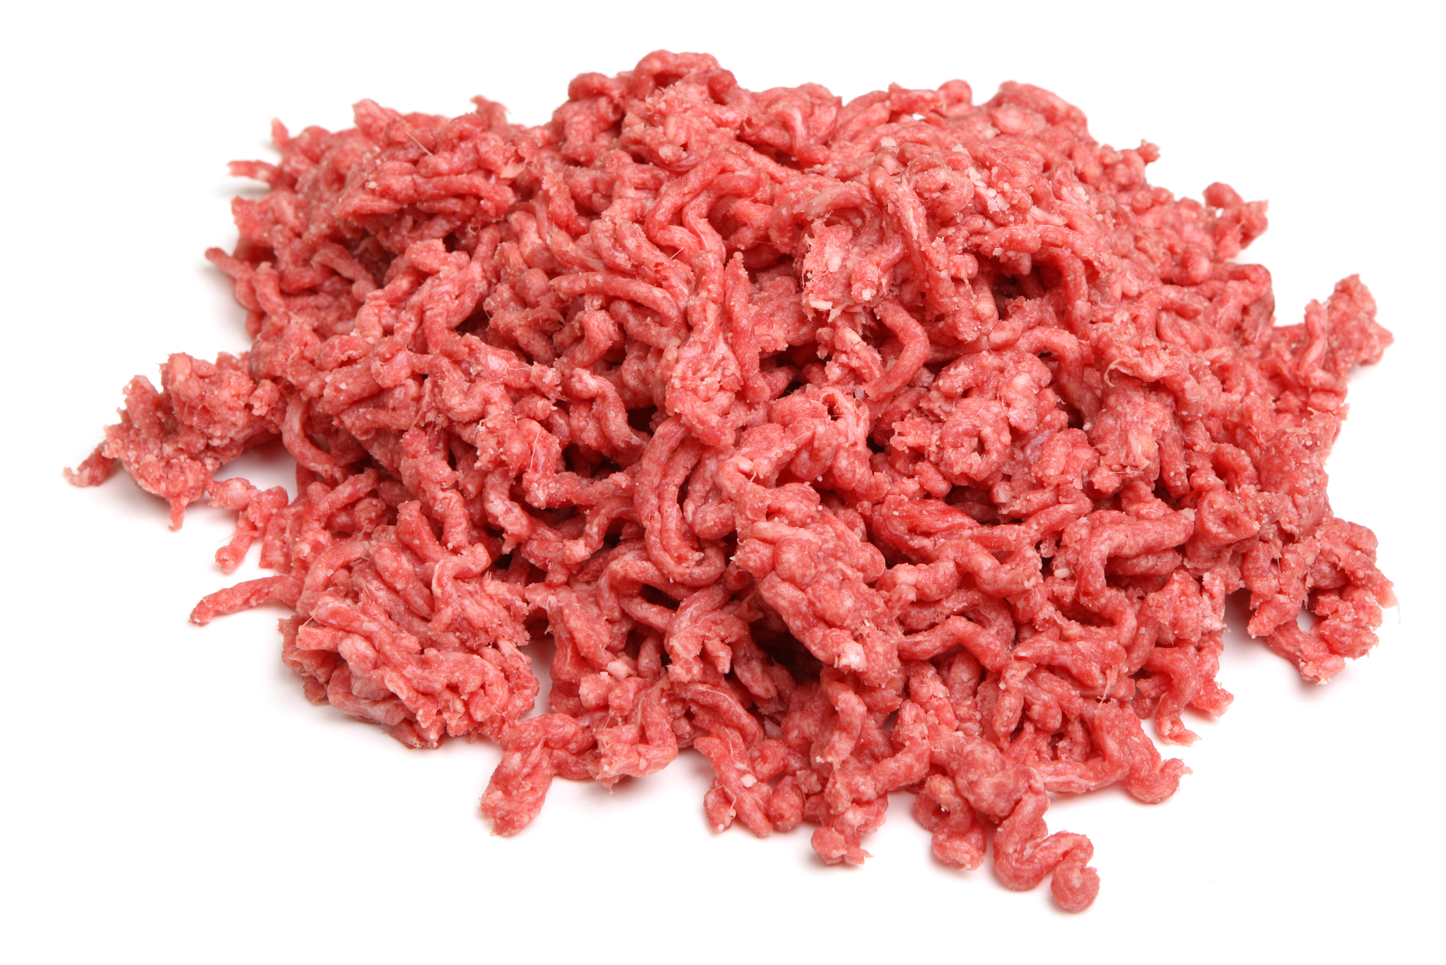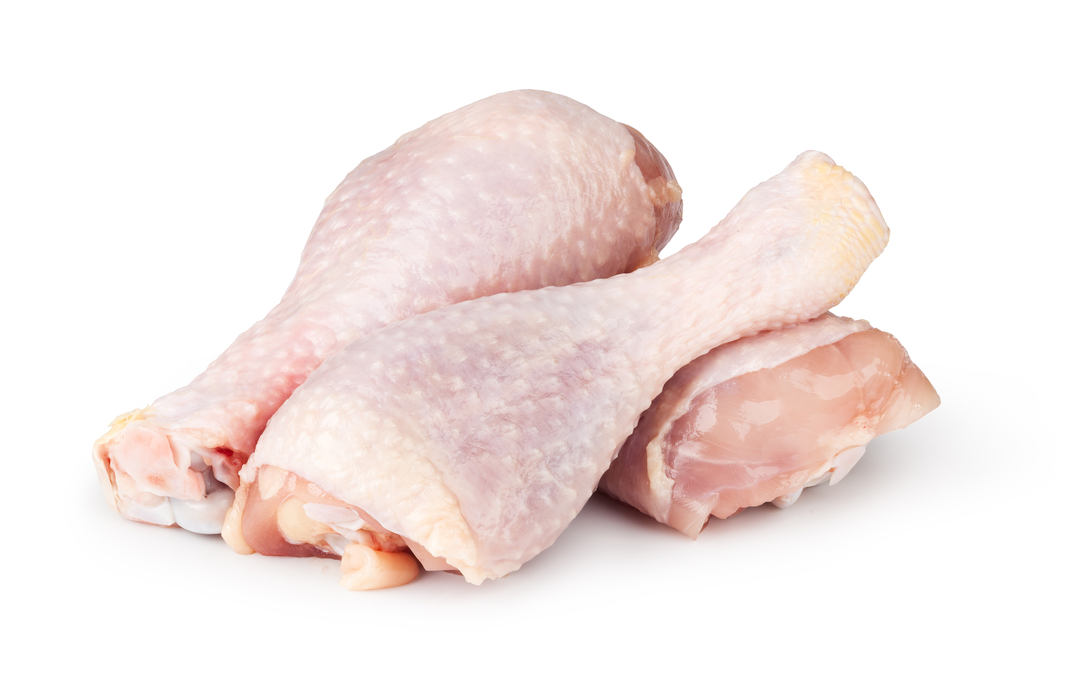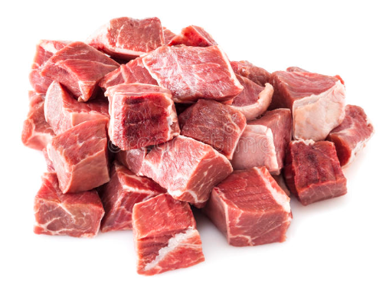
For more information, go to: https://bit.ly/3qlA8Bn
What is meat?
- Lean meat is the muscle tissue of animals which is made up of bundles of muscle fibres held together by creamy white connective tissue.
- Connective tissue is made up of two proteins called collagen and elastin.
- Two different types of fat can be found in meat, visible and invisible.
- The colour of meat varies due to the red protein called myoglobin and some haemoglobin remaining in the muscles. Exposure to oxygen increases the red colour of meat.
- Lean meat comprises water, protein, fats, vitamins, and minerals.

