Mini fruit cakes
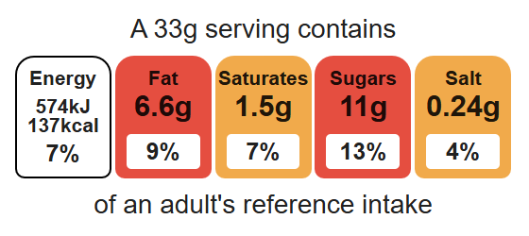
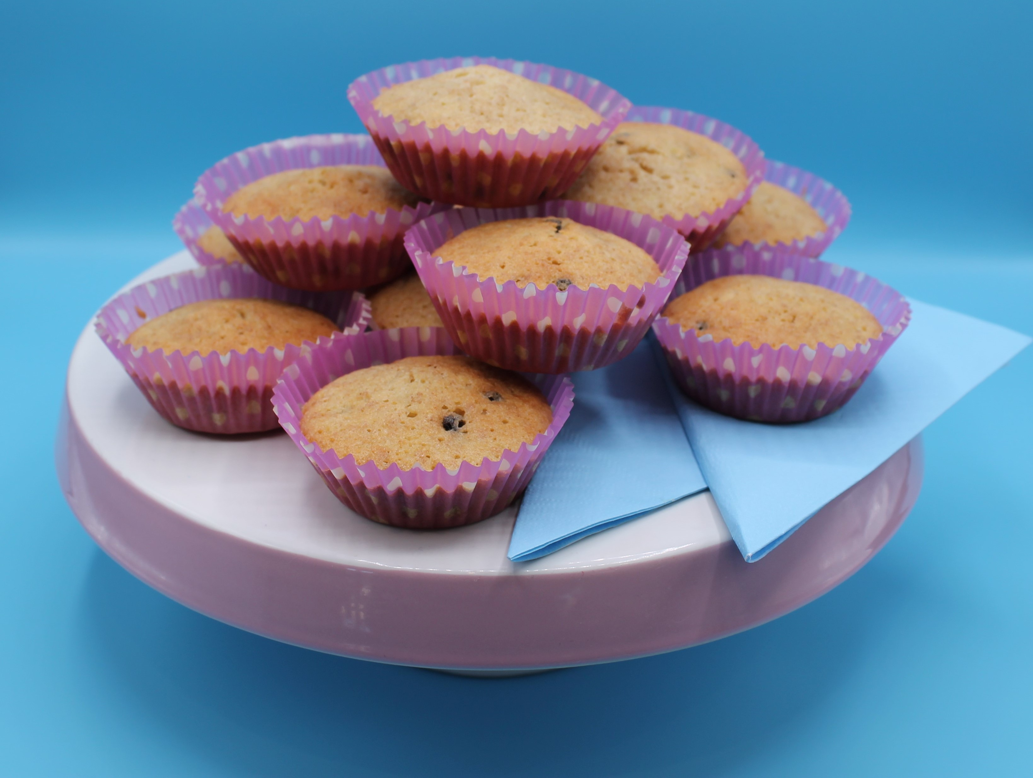
Complexity: low – medium

Ingredients (makes 12)

Equipment

12 cupcake cases

Cupcake tin

Weighing scales

Mixing bowl

Sieve

Mixing spoon

2 metal spoons

Cooling rack

50g self-raising white flour
50g self-raising wholemeal flour
2 eggs
100g caster sugar
100g reduced-fat spread
50g dried fruit, e.g. sultanas, cranberries, apricots

Method
- Preheat the oven to 200°C or gas mark 6.
- Place the cake cases in the cupcake tin.
- Sift the flour into the mixing bowl.
- Beat the eggs in a small bowl and add to the measuring bowl along with the sugar and fat.
- Mix everything together until light and fluffy.
- Stir in the dried fruit.
- Divide the mixture equally between the cake cases using 2 spoons.
- Bake for 15-20 minutes, until golden brown.
- Remove from the oven and allow to cool on a cooling rack.

Top tips
- Turn up the flavour: Add 1 x 5ml spoon cinnamon or ginger or use fresh or frozen fruit e.g. berries.
- Focus on fibre: Replace the white flour with 100g wholemeal flour for an extra fibre boost
- Reduce food waste: Use any leftover fruit e.g. fresh banana.

Food skills
Weigh, sift, mix, stir and combine, portion/ divide, bake.

