My lunch

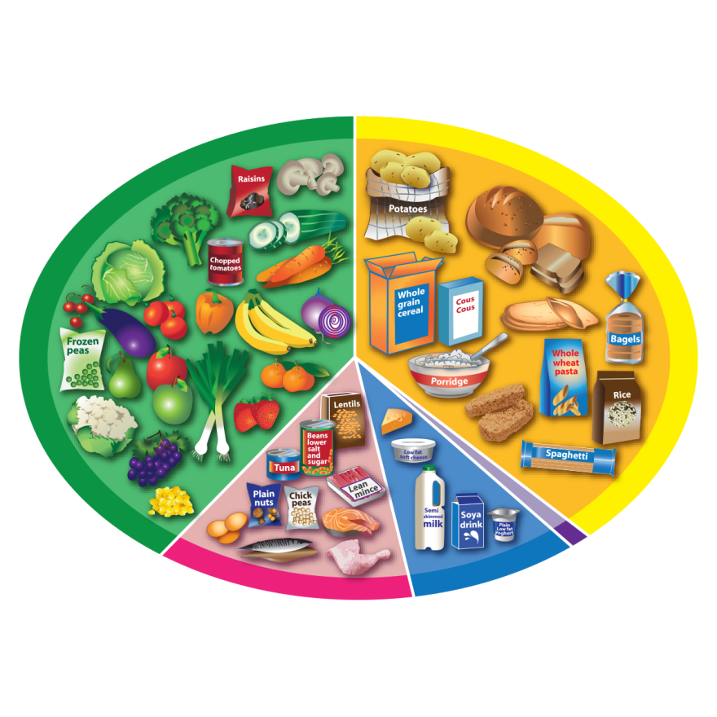
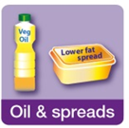
Plan a lunch with food from the Eatwell Guide.
Remember to add a drink!

