Wartime food
Wartime rationing
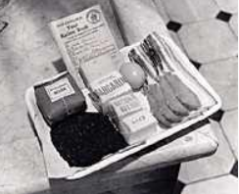
During the Second World War (1939-1945) the British government introduced food rationing to make sure that everyone received their fair share of the limited food which was available. Food rationing started in 1940 and finally ended in 1954. To start with only a few foods were rationed, but more foods were included as the years passed. The rations of food varied throughout the war and additional allowances were given to certain groups. Each person was given a ration book. A 'point' scheme was introduced for unrationed foods. Each person was allocated a number of points and a selected range of foods was given a point value. The consumer could choose how to spend these points. Many people were better fed during wartime food rationing than before the war years. Infant mortality rates declined, and the average age at which people died from natural causes increased. Eating Patterns The wartime food shortages forced people to adopt new eating patterns. Most people ate less meat, fat, eggs and sugar than they had eaten before. But people who had a poor diet before, were able to increase their intake of protein and vitamins because they received the same ration as everybody else.

The 'National Loaf'
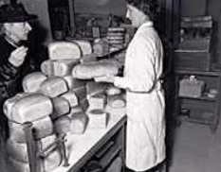
The 'National Loaf' was introduced. It was made with more of the grain than was used in white bread, resulting in a brown load. White bread was no longer readily available and brown bread became the norm. Special Diets Special arrangements were made for young children, expectant and nursing mothers to receive cod-liver oil, orange juice and milk from welfare clinics. When oranges were available children under six years of age were entitles to receive 1lb each week. The general health of children improved and on average they were taller and heavier than children before the war.

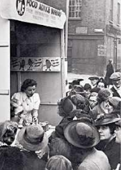
Ministry of Food
Part of the work of the Ministry of Food was to give advice to the British public about how to make the best of the food that was available. This included radio broadcasts, cookery demonstrations and recipe leaflets. 'Dr Carrot' and 'Potato Pete' were characters introduced to encourage people to eat home grown vegetables which were plentiful. Many people grew their own vegetables and kept hens to supplement their rations.

Woolton Pie
This pie was named after Lord Woolton, the Minister of Food. The vegetables could be changed according to what was available at the time.
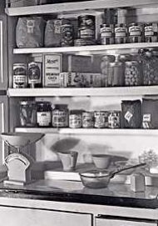
Ingredients | Method
500g potatoes 500g cauliflower 500g swede 500g carrots 1tsp marmite 25g oatmeal  4 spring onions 750g potatoes 25g cheese | 1. Dice and boil 500g of potatoes, cauliflower, swede and carrots in salted water.  2. Strain the vegetables, and save 200ml of cooking water.  3. Arrange the cooked vegetables in a large pie dish.  4. Add the marmite and oatmeal to the vegetable water and boil until thickened.  5. Pour the thickened liquid over the vegetables.  6. Add the chopped spring onions.  7. Boil and mash the remaining 750g of potatoes.  8. Top the pie with mashed potato and a little grated cheese.  9. Heat the pie in a moderately hot oven until golden brown (approximately 1 hour).  10. Serve with brown gravy.

Questions

1. Why was it important for people to grow their own vegetables to supplement their food rations?

2. a) What vitamins would babies and young children get from cod-liver oil?
b) Why are these vitamins needed?

3. a) What is the difference between the nutritional content of white and brown bread?
b) What health benefit might result from a change from white to brown bread?

4. Why would expectant and nursing mothers need orange juice in addition to their weekly rations?

5. What factors might have resulted in improved health during wartime? (Explain your answer)

