Potato preparation

Remember: wash, peel, re-wash
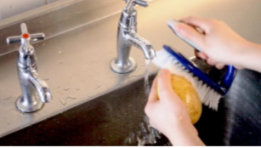

Wash

It is important to wash potatoes thoroughly by hand before you start any further preparation to remove soil and reduce dirt and grit.

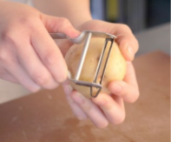
Peel

There are many different styles of peeler available. A speed peeler will minimise waste.

1. Hold the potato firmly in one hand. Keep finger tips out of the way.

2. Run peeler down the potato from top to bottom in smooth strokes.

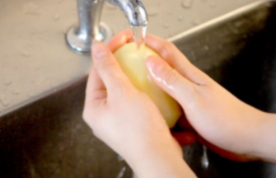
Re-wash

Re-wash potatoes after peeling to remove any last traces of soil and dirt.

Note: When you slice into a potato you expose its natural phenols (chemicals) to oxygen. This is what makes it go brown. Placing potatoes in cold water slows this process. Potatoes that have started to ‘brown’ are still safe to eat. The change in colour doesn’t change the taste.

Preparing potatoes in advance

1. Potatoes can be peeled and washed in advance and stored in cold water to prevent them from going brown.

2. Keep the prepared potatoes submerged, whole, in cold water in a cold place.

3. If you are storing potatoes for more than an hour they should be kept refrigerated. The longest potatoes should sit in water is overnight.

4. Small cuts, such as diced potatoes, will get waterlogged quickly so should only be placed in cold water for a short time, for example when preparing other ingredients.

5. When ready to cook; drain, cut and cover with fresh water.

6. If your dish relies on a crisp exterior, such as pommes Anna, potatoes should be cut immediately before use.

Ready prepared potatoes

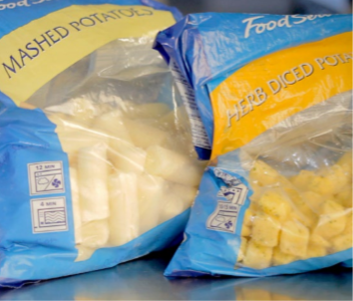
Ready prepared potatoes are available fresh, frozen, chilled or vacuum packed and are peeled, turned, cut and shaped for convenience. The majority of ready prepared potatoes are available frozen. In fact it is estimated that over seven million tons of frozen French fries are produced each year. Dehydrated potato flakes are used in mashed potato products, and as ingredients in some snacks. Potato flour is a dehydrated product used to bind meat mixtures and thicken gravy and soups. Potato starch is used as a thickener for sauces and stews.

Crisp manufacture

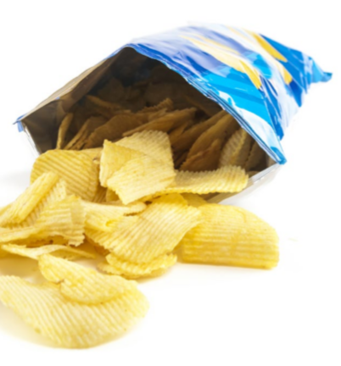
Potato crisps are made from fresh or stored potatoes. The potatoes are delivered to the factories where they are washed, peeled and sliced. The potato slices are fried in hot oil, and then flavours are added before they are packaged and sent to retailers. Crisp manufacturers work closely with the growers to ensure that the most suitable potato varieties are used and to ensure the highest quality available. Many manufacturers have their own potato stores, and crisp factories are often sited near to farms to minimise transportation costs and to avoid any undue stress on the potatoes. During harvest time fresh potatoes can be turned into crisps and packaged within an hour, and on shelves in supermarkets within a day or two.

Did you know?

Potatoes are also used for animal feed, glue and vodka!

Seed tubers are used to grow next year’s crop.

