Preparing chips from frozen

Why use frozen chips?

Across of range of sectors, frozen chips are used to offer high quality and consistent meal offerings that add value to the overall menu. There are many benefits of using frozen potato products, from ensuring consistency of the product being served, minimising preparation time and costs, to using only what you need and minimising any potential waste.

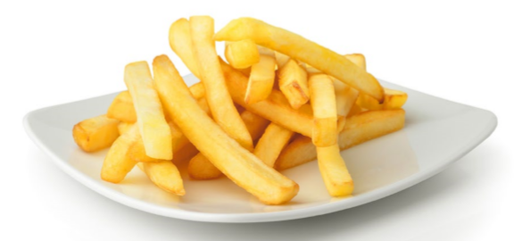

Best practice preparation from frozen

Clear cooking instructions will be included on pack, but always follow these practices:

1. Ensure the product is stored at the right temperature.

2. Check the oil temperature: oil should be to the fill line and heated to 175°C/350°F.

3. Weigh out 500g of product or half fill the fryer basket. DO NOT OVERLOAD.

4 Shake the basket gently halfway through cooking to break up any clusters.

5. Always cook to a light golden colour.

6. After frying, shake the basket to remove any excess oil.

Deep fry from frozen
2-3 minutes* | 175°C

*cooking times to be adapted depending on the product being cooked. Example shown is for the medium cut.

Top tips to maintain your oil
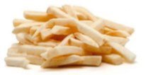
- Always ensure your oil is clean and cascaded daily.
- Do not use old or damaged oil as it will affect the quality of your final product.
- Ensure the correct oil temperature is used – this should be heated to 175°C.
- Avoid cooking different types of product in the same oil as this can taint the flavour.

