Potato storage and selection

Storage

Potatoes should be stored in a dry, dark and cool environment. For short term storage they should be kept at a temperature of 7-10°C. Avoid exposing them to light as this will encourage sprouting and eventually a greening effect. When stored at a constant temperature of 4°C, they can be kept for several months without affecting quality. However, temperatures below 4°C will convert the potato’s starch into sugar and will affect the taste and cooking qualities.

Did you know?

The green areas you sometimes see on a potato contain mild toxins. Once these areas are removed, the rest of the potato is safe to use.

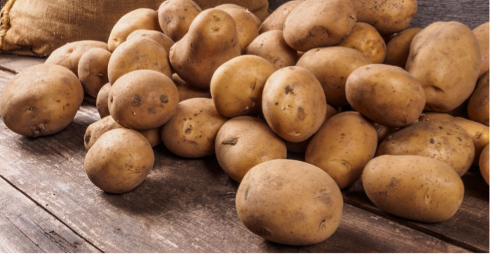

Quality Control

Choosing a good quality potato is the best start to any dish.
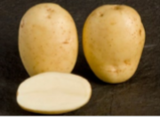

Go for potatoes that are firm, with smooth skin.

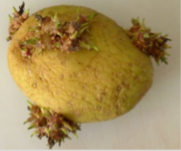
Avoid those with:
- withered or wrinkled appearance;
- cracked or damaged skin;
- weeping;
- bruising;
- excessive eyes, sprouts, green areas.

Checklist: before you start to cook
- Good quality texture and appearance.
- Good even size – this will help potatoes cook at the same rate.
- The right variety – check the table on the next page.

Choosing the right variety

Not all potatoes are the same. To get the best results you need to choose the right variety. You might not be able to find every variety in every shop but the most popular varieties should be available throughout the UK.

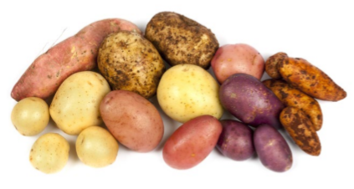


When cooked: | Fluffy in the middle
Perfect for: | Roasting, baking and chipping
Popular varieties: | King Edward, Maris Piper
Other varieties: | Cara, Golden Wonder, Rooster, Santa, Yukon Gold, Shetland Black, Highland Burgundy, Arran Victory, Violetta, Mayan Gold


When cooked: | A smooth texture. These potatoes hold their shape when boiled or cooked in liquid
Perfect for: | Mashing, boiling or as wedges
Popular varieties: | Desiree
Other varieties: | Lady Balfour, Vivaldi

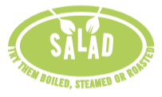

When cooked: | Firm to the bite
Perfect for: | Boiling, steaming or roasting whole in skins
Popular varieties: | Charlotte, Maris Peer
Other varieties: | Anya, Jazzy, Pink Fir Apple, Nicola, Pentland Javelin, Baby Gem

