Using pre-prepared potatoes

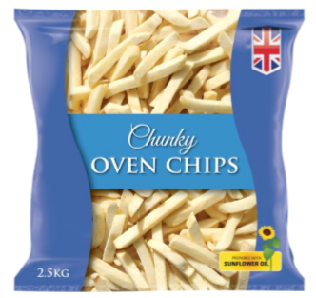
Why use pre-prepared potatoes?

Pre-prepared potatoes come in a variety of forms, but whether chilled or frozen, whole, diced or wedged, they help caterers to ensure consistent year-round product in their kitchens, taking away additional preparation time and costs. Pre-prepared potatoes can often be used as an ingredient to add variety to menus and can offer versatility to a chef to adapt to their menus. The most common storage methods for pre-prepared potatoes are chilled and frozen, to allow caterers to use products that suit their own operational practices. Some pre-prepared potato products also come as ‘dual storage’ meaning they may be delivered frozen, but can then be stored and used from a chilled state.

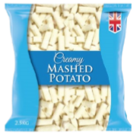
Best practice preparation

With such an array of products and their specific storage and cooking methods, always follow the cooking instructions that are clearly listed on pack.

Some general pointers with regards to best practice:
- where product can be dual stored, this will be clearly marked on pack;
- if cooking from chilled always check the recommended shelf life of the product;
- always cook to a light golden colour;
- do not overcook;
- always serve promptly for the best quality product.

Top oven tips
- Be aware of space available.
- Place oven trays on every other oven shelf to allow for an even cook.
- When oven baking, make sure you check the instructions on pack that is suitable for your equipment.
- Product should be evenly distributed in the cooking tray to ensure even cook

