Varieties: fact sheet

What is a potato?

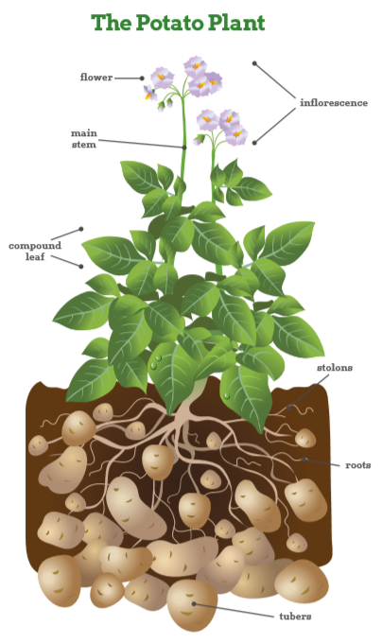
The potato is a starchy crop, which grows underground as a product of the potato plant. It is classified as a tuber, which is the fleshy swelling at the tip of an underground stem. The name ‘potato’ can refer to both the plant and the tuber.

There are over 4,000 edible varieties grown throughout the world and they are many different colours, shapes and sizes! Potatoes can have white, brown, purple or red skin; and white or gold flesh.

A brief history

Potatoes were discovered growing high in the Andes mountains of Peru, more than 6,000 years ago, and were first cultivated by the Incas. Having conquered Peru in 1536, the Spanish brought potatoes to Europe but for many decades they were used mostly for animal feed. Sir Walter Raleigh introduced potatoes to Ireland in 1589. They were introduced to the Colonies in 1621, and grown commercially in the US from 1719. Idaho, the present-day largest producer of potatoes, did not begin growing potatoes until 1836.

In the 1840s an outbreak of ‘potato blight’ swept through Europe, wiping out the potato crop in many countries. This ‘famine’ was particularly devastating in Ireland, where almost one million people died from starvation or disease.

The King Edward potato is one of the oldest surviving varieties in Europe.

The Coronation of King Edward VII in 1902 coincided with its introduction and it is claimed that the grower received Royal Assent to name the variety after the new King. Britain relied heavily on imported foods until the outbreak of WWII, which saw potato production double when food shortages meant we had to grow more for ourselves. Potatoes were energy-rich and replaced many ingredients, including bread flour, in wartime recipes. Potato Pete was a cartoon character used to promote potatoes on the radio (he even had his own song), in recipe books and on posters.

Potatoes have remained a staple part of British diets and, in 1995, potatoes were taken on board the space shuttle Columbia and became the first food ever to be grown in space. Today, around 300m tonnes of potatoes are grown globally and they are central to the diets of many countries across the world.

Varieties

Around 5.4m tonnes of potatoes are grown in Britain each year. ‘Home-grown’ potatoes account for around 80% of all the potatoes we eat. Approximately 100 different varieties are grown in Britain, but only 20 or so are widely available in the shops. The varieties that are available may depend on the region of Britain (reflecting what is grown locally), or the season. Potatoes are often referred to as ‘new’ (harvested in early summer) and ‘old’ (harvested in autumn).

New varieties

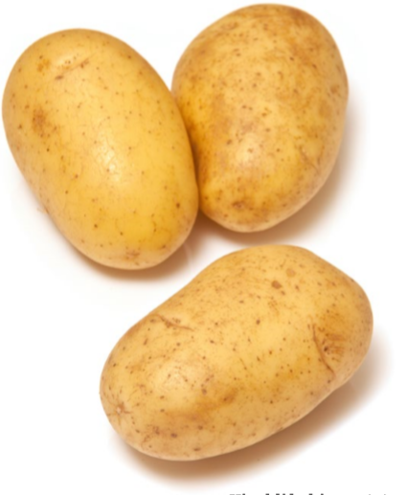
Growers are continually looking for ways to improve the quality of potatoes and productivity by breeding new varieties, which will have:
- increased resistance to pests and diseases;
- better storage qualities;
- greater nutritional value, such as more vitamin C;
- increased yield;
- greater consistency of size and shape for easier processing;
- improved eating quality and appearance;
- reduced needs for inputs such as water and fertiliser.

New and different varieties are developed by specialist potato breeders. It can take up to 15 years and significant financial investment to produce a new variety to be sold to consumers.

One recent success is ‘Vivaldi’, a variety which was developed to provide less energy than other potatoes. A related benefit is that it does not necessarily need butter to improve its taste when baked. It is grown in Britain and abroad and earned its name because it is available in all ‘four seasons’ of the year.

Know your potatoes

Although every variety is different, potatoes can be classified by their characteristics. The many varieties can be divided into three major groups or types:

Fluffy | Examples: Maris Piper and King Edward
Smooth | Example: Desiree
Salad | Examples: Charlotte and Maris Peer

Choosing the right variety

The different characteristics influence the performance of the potatoes when cooked in different ways. To get the best results, you need to choose the right variety for the cooking method you have chosen.

Fluffy potatoes have a fluffy middle when cooked and are perfect for jacket potatoes and chunky chips. The soft, dry texture when cooked means the edges can be ruffled for perfect crispy roast potatoes. They are not suitable as boiled potatoes as they tend to disintegrate.

Smooth potatoes hold their shape when boiled or cooked in a sauce such as ‘dauphinoise’ or in a hotpot or soup. They also make great mashed potato as they have a smooth texture when cooked.

Salad potatoes are firm to the bite and hold their shape when cooked. They can be boiled or steamed or roasted whole in their skins, but do not mash well.

The science behind the cooking

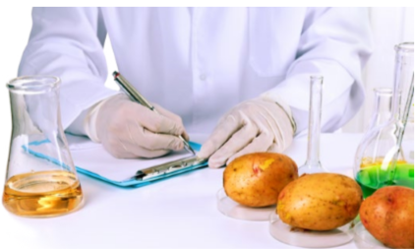
Potatoes vary from having a smooth to fluffy texture when they are cooked. The different textures are due to changes that happen to potato cells during cooking. During cooking, the starch in the potato begins to absorb water and swells in size. Potatoes need to be cooked for long enough to gelatinise the starch otherwise they will be ‘undercooked’. The starch cells of new potatoes are less mature which means they hold their shape well.

Did you know?
- There are over 5,000 varieties of potato found around the world. 3,000 varieties are only found in the Andes Mountains.
- A ‘spud’ is a narrow, small spade used in the past for digging potatoes. That’s how potatoes got their nickname.
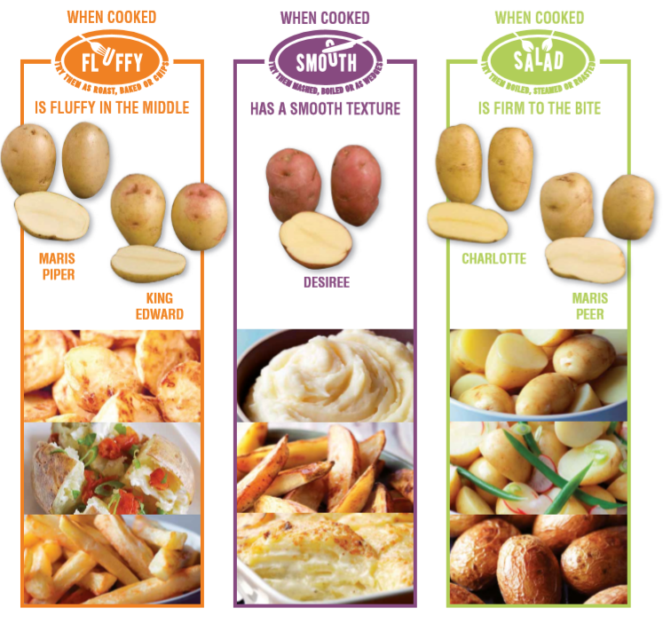
- The average person in Britain eats around 500 ‘spuds’ a year.

