Baking and roasting potatoes

Baking

Baking is the process of cooking food by surrounding it by heat.

Choose: fluffy potatoes such as Maris Piper, King Edward.

The science of baking

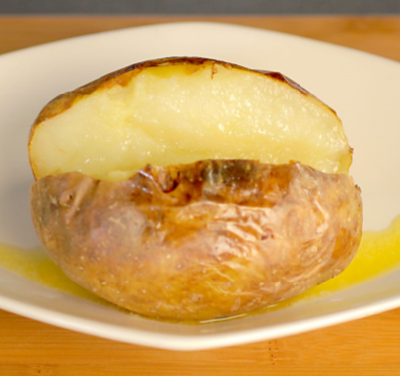
As the potato cooks, the skin acts as a seal, trapping water that expands and steams the potato during cooking. Small incisions must be made in the skin before cooking to allow the steam to escape. When potatoes are baked the skin becomes crisp and darkens. This is because the starch below the skin converts to sugar which browns in heat. Cut a slit in the potato as soon as it comes out of the oven so the inside does not steam. This will keep the potato light and fluffy inside. Baking is used as a cooking process in these potato dishes: pommes Anna, boulangere potatoes, Delmonico potatoes, fondant potatoes and macaire potatoes.

Did you know?

Delmonico potatoes are named after the New York restaurant where they were created. Delmonico potatoes date back to 19th century.

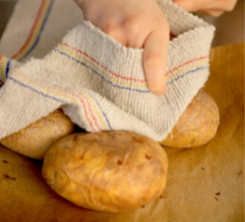
Recipe: baked jacket potatoes
- Preheat the oven to 230-250°C.
- Select good-sized potatoes (1 per portion), scrub well and prick all over with a fork.
- Place the potatoes on a baking tray or wire rack.
- Bake in the oven for around 1 hour, turning after 30 minutes.
- Test by holding the potato in a cloth and squeezing gently.
- They are ready to serve when they feel soft. Make a slit in the top and serve with your favourite topping.

For a quicker way to make a jacket potato, microwave until soft and cook in the oven for 10 minutes to crisp the skin.

Roasting

Roasting is the process of cooking food in the oven with the addition of oil or fat.

Choose: fluffy potatoes like King Edward, Maris Piper.

The science of roasting
Basting the potatoes by spooning over hot oil moistens them while cooking. Roast potatoes should be served immediately. Potatoes will carry on steam cooking inside and the skins will go soft if not served straight away.

Roasting is used as a cooking process in these potato dishes: chateau potatoes and noisette potatoes.

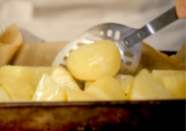
Recipe: perfect roast potatoes
- Wash, peel and rewash potatoes.
- Cut into even sized pieces and dry well.
- Par-boil slowly until just cooked on the inside.
- Drain, toss in oil and roast in the oven at 220°C for 15 minutes.
- Reduce the temperature to 180°C and baste every 5 minutes until they have a crisp coat all over.

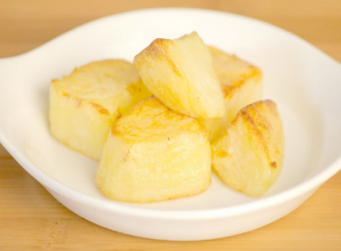
Recipe: easy roast potatoes
- Wash, peel and rewash potatoes.
- Cut into even sized pieces and dry well.
- Heat oil in a roasting tray, then add the potatoes and lightly brown on all sides.
- Cook for about 1 hour in the oven at 230-250°C.
- Turn the potatoes after 30 minutes and cook until golden brown.

