Boiling and steaming potatoes
Boiling
Boiling is the process of cooking food in boiling liquid over a direct heat.
Choose:
- salad potatoes such as Charlotte and Maris Peer for boiled potatoes;
- smooth potatoes such as Desiree if you wish to mash potatoes after boiling.

The science of boiling
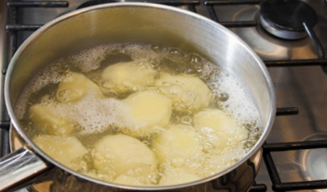
Boiling is a healthy method of cookery as it does not use any fat. The food is covered in liquid and heated to boiling point. The heat is then reduced for the remainder of the cooking time. Potatoes must be boiled correctly so not to lose nutritional value/flavour.
When potatoes are boiled, the starch in the potato absorbs water and swells during the cooking process. This gives the potato a better texture and flavour, and makes it easier to digest.

The starch cells of ‘new’ potatoes are immature. To help break down these cells new potatoes are scraped and washed, and then cooked in water that is already boiling. This also helps to preserve vitamin C.
Boiling potatoes is often combined with other processes when cooking potatoes.
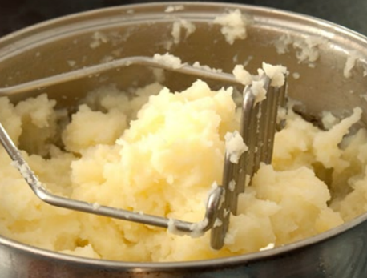
Boiling is used as the first process in all of these dishes:
- croquette potatoes;
- Delmonico potatoes;
- macaire potatoes;
- mashed potatoes;
- duchess potatoes;
- roast potatoes;
- sauté potatoes;
- chateau potatoes.

Recipe: perfect plain boiled potatoes
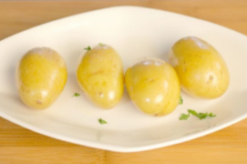
- Wash, peel and re-wash smooth potatoes and cut into even sized pieces.
- Alternatively, wash salad potatoes well.
- Cover with cold water.
- Bring to the boil.
- Reduce heat to simmer and cook gently for approximately 20 minutes.
- Serve plain or use for potato salad.

Steaming
Steaming is the process of cooking potatoes using steam from boiling water.
Choose:
- salad potatoes such as Maris Peer or Charlotte.

The science of steaming
Always choose evenly sized potatoes so that they cook in the same amount of time. If the potato is going to be cooked further it is best to leave the skin on during steaming. The skin will protect the potato from the steam.
Steaming retains more flavour than boiling. Steaming is used as a cooking process in these potato dishes: sauté potatoes, Lyonnaise potatoes, fondant potatoes.

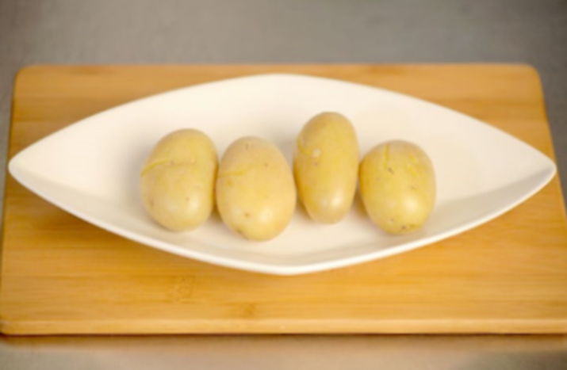
Recipe: steamed potatoes
- Wash the potatoes well.
- Place the potatoes in a steamer over boiling water.
- Steam until tender.
Did you know?
The steaming process preserves the potato’s nutrients, especially when the skins are left on, and makes them easier to digest and absorb into the body.

