Frying potatoes

Shallow frying (sauté)

Sauté is the process of cooking food quickly in a shallow pan with a minimum of fat.

Choose: fluffy potatoes such as Maris Piper or smooth potatoes such as Desiree.

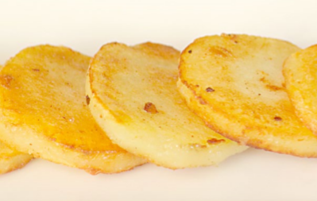
The science of shallow frying

The potatoes are in direct contact with the fat, so they cook rapidly. The high temperature seals the surface of the potato almost instantly and prevents the natural juices from escaping.

Shallow frying enhances the colour and flavour of the potatoes. Shallow frying is used as a cooking process in these potato dishes: pommes Anna, macaire potatoes, noisette potatoes, parmentier potatoes, rosti.

Recipe: sauté potatoes
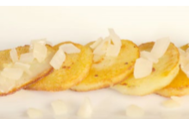
- Scrub small to medium, even-sized potatoes. Do not peel.
- Plain boil or steam the potatoes for approximately 15 minutes.
- Cool slightly, then peel.
- Cut into 3mm slices.
- Heat a small amount of oil in a frying pan and toss the slices in the hot oil, until light brown.
- Serve.

Did you know?

Sauté potatoes are often served with shallow-fried onions. This dish is known as pommes Lyonnaise. The onions should be fried slowly in oil, turning frequently until tender and brown.

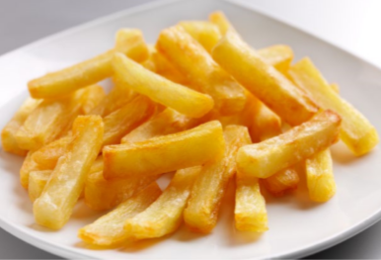
Deep frying

Deep frying is the process of cooking food immersed in hot oil or fat.

Choose: fluffy potatoes such as Maris Piper, King Edward.

The science of deep frying

Cooking cut potatoes in small quantities will allow the oil to regain its temperature more quickly, so the chips cook faster and absorb less fat. The ideal temperature for the oil is 175°C. If the oil is too hot, the food will brown, but be raw on the inside.

Recipe: chips
- Wash, peel and rewash the fresh potatoes.
- Cut into slices approximately 1cm thick.
- Cut the slices into strips, roughly 5cm x 1cm x 1cm.
- Wash well and dry with a cloth.
- Blanch in water just below boiling point for 8 minutes, drain and allow to dry.
- Deep fry in oil heated to 165°C for 6 minutes until tender but with no colour. This cooking technique is called par-frying and involves partially frying the food but not browning it, so that it must be cooked again before serving.
- Shake the chips to stop them sticking to each other, or the basket.
- Remove, drain on absorbent paper and reserve until required. Chips can be frozen at this point.
- When required, heat the oil to 175°C and deep fry in small batches until crisp and golden.
- Drain well and serve.

Tip: for the best chips, always follow these guidelines.

Before frying:
- Check the oil and if it is too dark, it needs replacing.
- Heat oil or fat to the correct temperature of 175°C.

During frying:
- Never fill the frying basket more than halfway.
- Gently shake the basket halfway through cooking to break up any clusters.
- Never take chips out before the end of the cooking time.

After frying:
- Remove excess fat or oil by shaking in the basket.
- Place chips on absorbent paper.
- Don’t heat the oil for longer than needed.
- Don’t use the same oil too many times.

