Knives and other kitchen cutting equipment factsheet

Remember: select appropriate knives and other cutting equipment when preparing potatoes. Always use knives correctly at all times. Know how to handle, maintain and care for knives and other cutting equipment.

Selecting the right knife

Choose a sharp, wide-bladed ‘Cook’s’ chopping knife. The blade should be just longer than the potato.

Handling knives

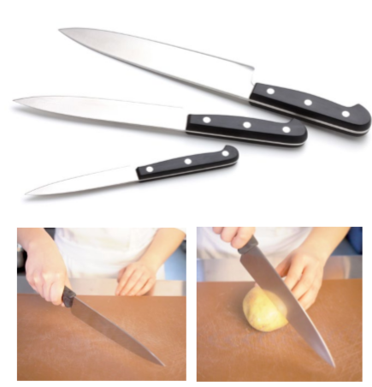
Hold the knife with your finger around the handle, with your thumb and index fingers on opposite sides and well clear of the blade edge. Grasp the knife firmly for full control. Fingers and thumb of your free hand must be tucked in.

Handling knives

Hold the knife with your finger around the handle, with your thumb and index fingers on opposite sides and well clear of the blade edge. Grasp the knife firmly for full control. Fingers and thumb of your free hand must be tucked in.

Cutting potatoes

Potatoes need to be cut in different ways for different cooking methods and dishes.

Tip: Keep knives sharp to cut efficiently and cleanly.

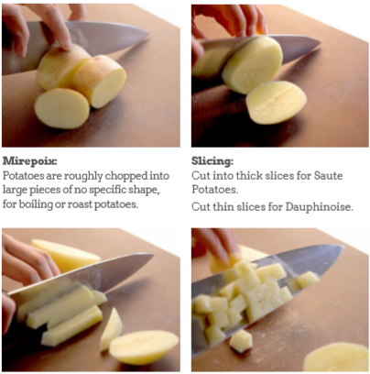

Mirepoix: potatoes are roughly chopped into large pieces of no specific shape, for boiling or roast potatoes.

Slicing: cut into thick slices for sauté potatoes. Cut thin slices for dauphinoise.

Strips: cut into strips for chips or French fries.

Dicing: cut into the right size of dice for dishes such as parmentier potatoes and Delmonico potatoes.

Sharpening knives: using a sharpening stone:
- Place the stone on a damp cloth.
- Hold the knife at a 20-degree angle.
- Draw the whole blade across the stone using a free hand to apply even pressure.
- Turn the blade over and repeat.
- Repeat several times on each side.
- Clean the knife after sharpening.
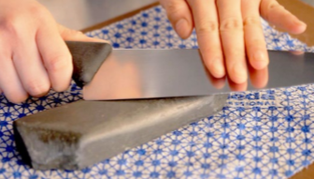

Cleaning knives:
- Keep both the handle and blade clean.
- Wash thoroughly between tasks using detergent sanitizer.
- Rinse using very hot water.
- Dry thoroughly using absorbent paper.
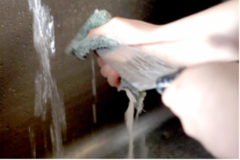

Sharpening knives: using a steel:
- Hold the steel in one hand with fingers behind the guard.
- Hold knife at a 20-degree angle.
- Slide knife blade from handle to point.
- Repeat several times on each side.
- Clean the knife after sharpening.

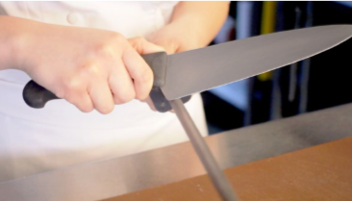

Storing knives:
- Store knives in a case, wooden block or magnetic rack.
- Never store knives loosely in a drawer or locker.

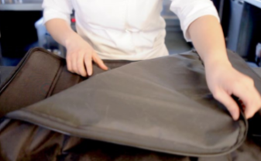

Knives and other kitchen cutting equipment

For grating

Use a box grater to prepare rosti.

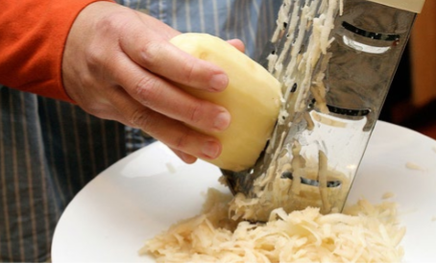

For mashing

Use a traditional potato masher, potato ricer and a sieve/mouli for perfect mashed potato.

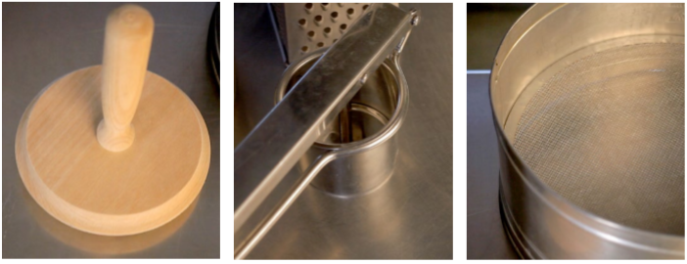

For slicing thinly

Use a mandolin to cut thin slices for dauphinoise or boulangere potatoes. Place the mandolin on a stable surface. Take extra care with the last few slices!

