Mashing and piping potatoes

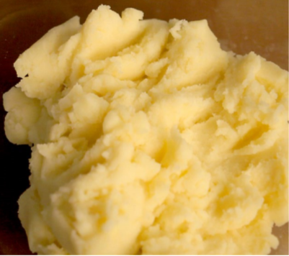
Mashing
Mashing is the process of reducing a food to a pulpy mass by crushing.

Choose: potatoes with a smooth texture such as Desiree.

The science of mashed potato
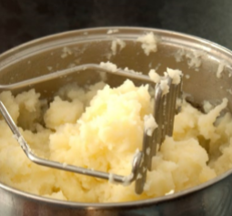
When the potato is mashed, the cells break open, releasing starch which makes them creamy and smooth. If adding a small amount of butter or spread, add when you begin mashing. The fat coats the cells and the starch so that they absorb less liquid. This makes the potatoes fluffier and stops them from becoming gluey. The slower the potatoes are cooked, the better for the starch as it has more structure in the final mixing process.

Recipe: mashed potato
1. Wash, peel and rewash the potatoes.
2. Cut to an even size.
3. Cook in water or steam.
4. Drain off the water as soon as they are cooked, cover and return to a low heat to dry out the potatoes.
5. Pass through a sieve or mouli (potato ricer).
6. Return the potatoes to a clean pan.
8. Gradually add warm milk, stirring continuously until a creamy consistency is reached.

Ingredients
500g smooth potatoes such as Desiree
30ml milk, warmed

Piping
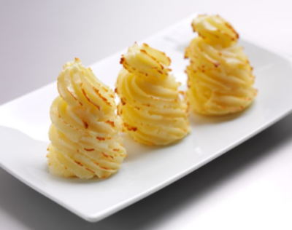
Adding egg and seasoning to mashed potato creates a ‘duchess potato’ mix, which can be piped or hand moulded. The mixture is slightly stiffer than mashed potato and can be piped into many shapes including spirals (duchess potatoes), nests (marquis potatoes) or straight cylinders (croquette potatoes).

Choose: potatoes with a smooth texture such as Desiree.

Recipe: duchess potatoes
1. Cook the potatoes as for mashed potato.
2. Return the drained potatoes to the heat to dry as much as possible, then pass through a sieve or mouli and place in a clean pan.
3. Add the egg yolk and stir in vigorously with a wooden spoon.
4. Mix in the butter and correct the seasoning.
5. Place in a piping bag with a large star tube and pipe into neat spirals about 5cm wide and 5cm tall on a greased baking sheet.
6. Place in a hot oven at 230°C for 2-3 minutes to firm the edges slightly.
7. Remove from the oven and brush with egg wash.
8. Brown lightly in the oven or under a salamander.

Ingredients
600g smooth potatoes such as Desiree.
1 egg yolk
Seasoning

Did you know?
The French name for duchess potatoes is ‘pommes de terre duchesse’ – they are a classic item of French cuisine.

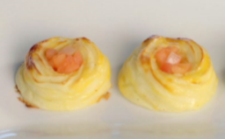
Try something different: marquis potatoes
1. Pipe nests using the duchess potato mix.
2. Sauté onions and tomatoes. Mix together, season and leave to cool slightly.
3. Fill the nests with the tomato mix, and serve.

