Pork jambalaya

Ingredients
Complexity: Medium-high
400g pork medallions
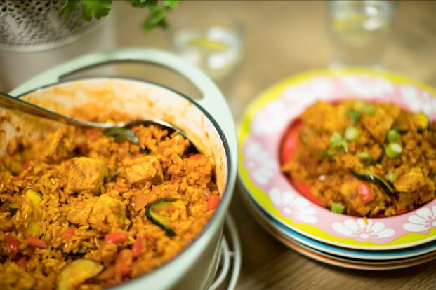1 onion
2 garlic cloves
5 Spring onions
½ red pepper
100g button mushrooms
1 Courgette
Spray oil
1 x 5ml spoon mild chilli powder
2 x 5ml spoon ground turmeric
225g easy cook brown rice
450ml pork stock
1 x 400g can chopped tomatoes
Ground black pepper
3 Whole cloves

Equipment
Red board, vegetable knife, chopping board, garlic crusher, large saucepan with a lid, heat resistant spoon or wooden spoon, measuring spoons, measuring jug, plate

Method
- Remove any visible fat from the pork.
- Cut the pork into cubes. Thoroughly wash and dry your hands after touching the raw meat.
- Prepare the remaining ingredients:
  - peel and dice the onion;
  - peel and crush the garlic cloves;
  - slice the spring onions into circles, reserving some green tips for garnish;
  - deseed and dice the red pepper;
  - quarter the button mushrooms;
  - halve the courgette and slice diagonally.
- Spray the oil into the pan and allow to heat.
- Add pork to pan, stir and allow to brown.
- Remove browned meat from the pan, and place on a clean plate.
- With the pan still on the heat at the onion, garlic, chilli powder, turmeric and brown rice.
- Stir well and cook until the rice turns opaque.
- Add the stock and the tomatoes.
- Season with freshly ground black pepper.
- Sir well and turn up the heat to boil.
- Cover with a lid and simmer for 20 minutes.
- Add the pork, whole cloves, spring onions, red pepper, mushrooms and courgettes and stir well.
- Cook for a further 10 minutes, or until the liquid is absorbed. Stir occasionally.
- Sprinkle with the reserved green tops of the spring onions and serve.

Top tips
- For more tender meat, cut across the grain
- Use reduced salt vegetable stock for a lower salt content
- Serve with a crisp green salad.

Food skills
- Trim
- Cut
- Peel
- Dice
- Crush
- Slice
- Fry
- Simmer / boil
- Weigh
- Measure

