Quesadillas

Ingredients
Complexity: Medium-high
100g chorizo sausage
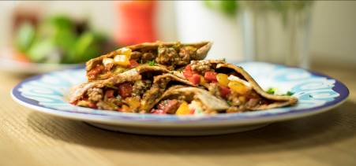2 garlic cloves
2 spring onions
1 red pepper
1 yellow pepper
2-3 x 15ml spoon fresh coriander
1 x 150g mozzarella cheese
375g lean beef mince
Large pinch dried chilli flakes
Freshly milled black pepper
8 wholemeal or seeded tortilla wraps
4 x 15ml spoon tomato chutney

Equipment
Chopping board x 2, vegetable knife, large non-stick frying pan x 2, heat resistant silicone spoon or wooden spoon, pan stand, teaspoon, large plate, fish slice.

Method
- Prepare the ingredients:
  - roughly cube the chorizo;
  - crush the garlic cloves;
  - slice the spring onions into circles;
  - deseed and finely dice the red pepper;
  - deseed and finely dice the yellow pepper;
  - chop the coriander;
  - roughly tear the mozzarella.
- Place the beef mince and the chorizo in the frying pan and dry fry until the mince in browned.
- Add the garlic, onions and red/yellow peppers to the pan.
- Stir and cook for a further 5-10 minutes.
- Sprinkle in the chilli flakes and grind in the black pepper.
- Stir well.
- Add the chopped coriander and stir.
- Remove the pan from the heat.
- Place one tortilla on a chopping board.
- Spread with 1 x 5ml spoon chutney leaving a 1cm gap around the edge.
- Add a quarter of the beef mixture and spread over the chutney.
- Sprinkle over a quarter of the torn mozzarella.
- Top with another tortilla and press down gently.
- Slide the filled tortilla into the frying pan.
- Cook for 2-3 minutes.
- Invert onto a plate.
- Return to pan.
- Cook the other side for 2-3 minutes or until the cheese melts.
- Remove the tortilla from the pan and slice into quarters.

Top tips
- Use extra lean beef mince and use less chorizo to reduce the fat content of the dish
- Instead of tomato chutney, why not try chipotle paste instead. Be careful though, it is spicy!
- Use the back of the teaspoon to spread the chutney.

Food skills
- Cut
- Crush
- Slide
- Chop
- Fry
- Stir
- Spread
- Weigh
- Measure

