Sensory and nutrition worksheet

Sensory activity

Set up a sensory test – sample white, brown and wholemeal bread samples. Consider how the flour has been processed – how has this affected the sensory properties?

Bread sample | Sensory comments | Effect of processing

White

Brown

Wholemeal

Nutrition activity

Below are the nutrition panels for white, brown and wholemeal bread. Consider how the flour has been processed – how has this affected the nutrition properties?

Bread sample | White* | Brown* | Wholemeal*
Nutrition information | 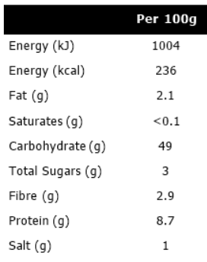 | 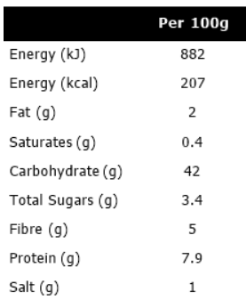 | 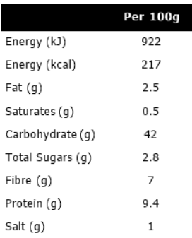

Effect of processing

*average loaf

