Viscosity
Place the sheet on the work surface and put a small scone ring in the centre.
Pour sauce into the scone ring.
Pull up the scone ring, releasing the sauce.
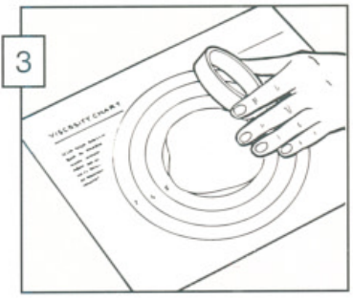
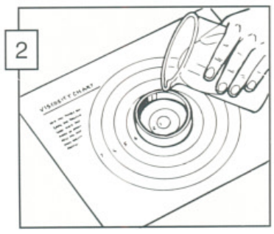
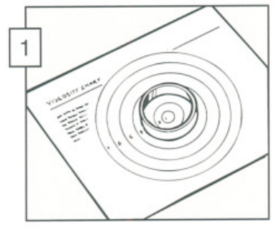
Count to 10 and measure how far the sauce spreads.
1
2
3
4
5
0

