Practical task record sheet – Summer lamb kebabs with cauliflower couscous
Ingredients
Zest and juice of 1 lemon
1 garlic clove
1 x 15ml spoon olive oil
1 x 15ml spoon dried basil
Freshly ground black pepper
150g lean lamb (boneless leg steaks are ideal)
1 courgette
12 cherry tomatoes
½ small cauliflower (florets should weigh about 175g)
Low calorie spray oil
4 wooden skewers

Equipment
Grater, knife, chopping board, juicer, garlic press, large mixing bowl, red chopping board, mixing spoon, cling film, 4 wooden skewers, tin foil, grill tray, pastry brush, food processor, large non-tick frying pan

Method
- Prepare the marinade:
  - wash and zest the lemon and place in a mixing bowl;
  - juice the lemon and add 2 x 15ml spoons of juice to the zest (reserve the rest of the juice for the cauliflower couscous);
  - peel and crush or finely chop the garlic and add to the bowl;
  - add the olive oil, dried basil and freshly ground black pepper and stir well.
- Using a red chopping board, cut the meat into 2cm cubes removing any fat or connective tissue.
- Add the cubes of meat to the marinade and stir well. Thoroughly wash and dry hands after touching raw meat. Cover and place in the fridge for 20 minutes.
- Soak the wooden skewers in water to prevent them burning under the grill.
- Prepare the vegetables:
  - wash cherry tomatoes;
  - wash courgette, top and tail and chop into 1cm cubes.
- Pre-heat the grill and line the grill tray with tinfoil. This will make it easier to wash up afterwards.
- Remove the meat from the fridge and assemble the kebabs. Be careful as the skewers are sharp. Wash hands again after touching the raw meat.
- Place the kebabs on the grill tray and brush the vegetables with the left over marinade.
- Cook for approximately ten minutes, turning the kebabs now again to ensure that they are cooked evenly.

To make the cauliflower couscous
- Remove any outer leaves and roughly chop the cauliflower.
- Place in a food processor and blitz until the mixture resembles couscous or small grains.
- Spray a large frying pan with spray oil and heat. Add the cauliflower and cook for 6-8 minutes.
- Remove the pan from the heat and add 1 x 15ml spoon lemon juice. Stir well.
- Serve with the summer lamb kebabs.

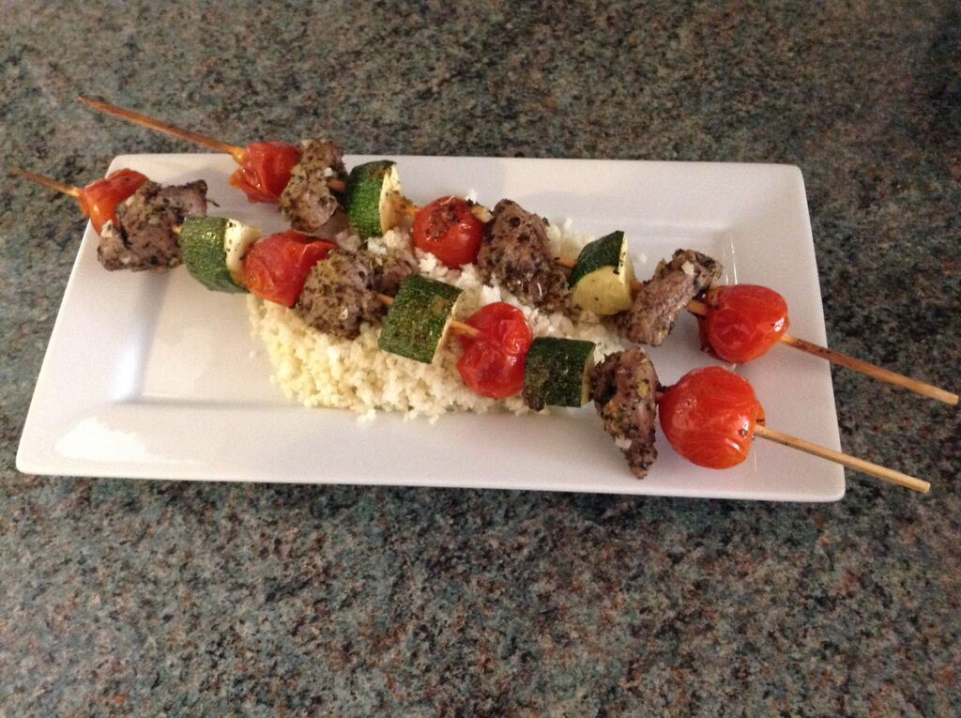
List the steps necessary to ensure that the final dish is safe to eat:

Which Eatwell Guide food group have you used?
Potatoes, bread, rice, pasta and other starchy carbohydrates
Fruit and vegetables
Dairy and alternatives
Beans, pulses, fish, eggs, meat and other proteins
Oils and spreads

Skills groups/techniques | ✔ | Comments
Knife skills – meat, fish and alternatives
Prepare fruit and vegetables
Prepare, combine and shape
Tenderise and marinate
Select and adjust cooking process
Weigh and measure
Preparation of ingredients and equipment
Use of equipment
Water based methods – hob
Dry heat and fat based methods – hob
Using the grill
Using the oven
Make sauces – blended, reduction, emulsion
Set a mixture – removal of heat (gelation)
Set a mixture – heating (coagulation)
Use of raising agents
Make a dough
Shaping and finishing a dough
Test for readiness
Judge and manipulate sensory properties

