How does it cook? Answers

Questions/tasks:

- Many foods such as fruit and vegetables are good to eat raw; however most of the food we eat is cooked. State five reasons why we cook food:

- To prevent food poisoning by destroying microorganisms
- To make it easier to digest
- To improve palatability by changing its flavour and texture
- To preserve it
- To improve absorption of nutrients.

2. Explain the term heat transference (heat exchange) in cooking.

Heat is a form of energy. When heat is applied to food, it changes both the chemical properties and the physical appearance of food. During the cooking process changes are likely to take place to the colour and texture of the food, e.g. meat will shrink during roasting because the heat forces moisture to the surface where it evaporates. There are three basic methods of transferring heat:
- conduction;
- convection;
- radiation.

Heat can be transferred using wet or dry methods of cooking.

3. Complete the following chart to show the main methods of heat transfer (heat exchange) and how they work:

Method | What happens? | Example methods of cooking
Conduction | Everything is made up of vibrating molecules, when energy (heat) is applied they vibrate faster, collide with each other and pass on the energy in a chain reaction. In the saucepan heat is applied at the base, the energy is passed from the nearest molecules to the furthest point. Heat will always travel from the warmest to the coolest point. Conduction takes place in both the container, e.g. saucepan and the food itself.  Some materials are better conductors than others, saucepans should be good conductors. | Frying, boiling, roasting, baking microwave
Convection | Convection takes places in gas and liquids. As molecules are heated they expand and become less dense (lighter). These lighter molecules float upwards while denser (cooler and heavier) sink down and replace them. Convection takes place when using liquids, e.g. when food is boiled. It also takes place in the oven when air circulates around food. | Baking, boiling, frying, oven roasting
Radiation | Radiation is the direct transfer of energy from the heat source to the food. There are many types of radiation waves (x-rays, radio). In cooking three types of waves are used – visible, infra-red and microwave. When using the first two the radiated waves heat the surface of the food, the centre of the food is heated by conduction.  Microwave cooking uses a different type of radiation wave. In the microwave oven the magnetron converts electrical energy into microwave energy. These waves can penetrate deeper into the food and make it a very fast method of cooking. They make water molecules vibrate creating friction which makes heat.  Food cooked by radiant heat only is often thin and cooks quickly, e.g. toast. | Grilling, microwave, barbeque, spit roasting

4. Explain the following methods of cooking that can be used for meat. Give an example recipe for each. An example has been completed.

Stewing/casseroling  Food is cooked in a small amount of liquid at simmering point. Liquid is part of the dish to be served and gives flavour. The method requires long slow cooking. It is suitable for exonomical cuts of meat which can be made tender.  A stew is prepared and cooked on top of the cooker. A casserole is prepared on the hob and cooked in the oven.  Example:  Beef and beetroot casserole  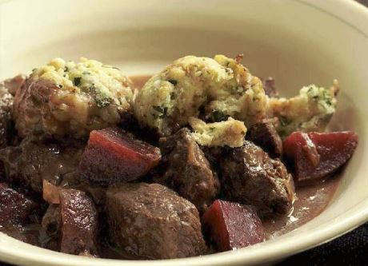 | Pot roasting  Meat is browned initially then cooked in a covered container which retains the steam given off by the meat. This gives a moist finish to the dish.  Example:  Pot roast shoulder of lamb  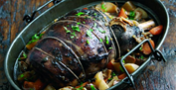
Grilling  Fast method of cooking using intense heat from an electric element, gas flame or barbecue. The heat source can be above or below the food. Little or no additional fat is used; some fat in the food melts and drips away.  Example:  Pork, lime and mint stuffed peppers  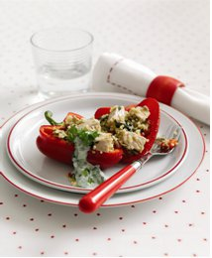 | Shallow frying  Food is cooked in a small amount of fat or oil. High or low temperatures can be used. Food will absorb fat especially if the temperature is too low. Coatings can reduce this.  Small pieces of food can be cooked at very high temperatures in a wok, this is called stir frying.  Example:  Lamb quesadillas  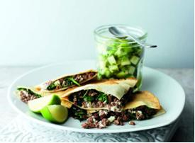

Braising  Food is cooked in a container which is closed for all or most of the cooking time. There are three stages:  1 Selection of chopped root vegetables are prepared and placed in the dish (mirepoix)  2 The meat is browned, placed on top of the vegetables and a liquid is added  until the meat is 2/3 covered  3 The container is covered with a lid, brought to the boil on a cooker, transferred to the oven to complete the cooking at simmering point.  Example:  Braised beef with star anise  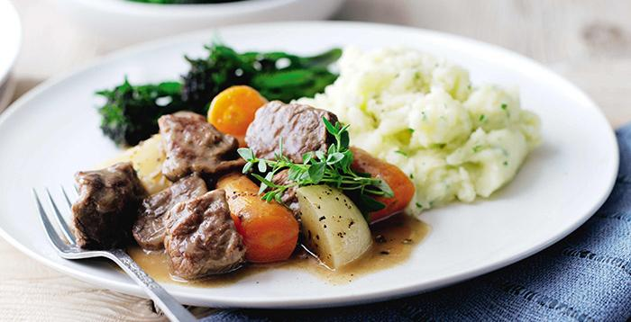 | Roasting  Food is cooked by dry heat in a hot oven or on a spit. Small amounts of fat are used to prevent drying out. High temperatures increase shrinkage and loss of juices in the meat.  Water and fat soluble vitamins are lost.  Example:  Roast lamb cutlets with pumpkin  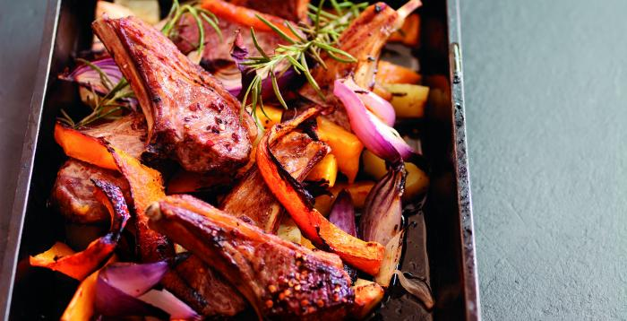
Barbecuing  This method is the same as grilling but is usually done in the open air.  The use of charcoal gives flavour to the food, it can also be basted with a marinade or sauce to prevent it drying. Some fat may be used to keep food moist and prevent sticking.  Example:  Alfresco beef kebabs  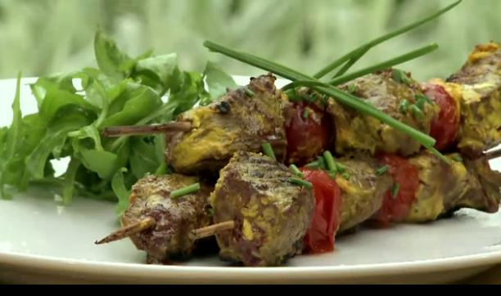 | Microwave  Foods cooked in the microwave often remain pale and moist as no external heat is used. Some foods are more successful than others.  Water soluble vitamins are retained due to the small amount of liquid used and the rapid cooking time.  Example:  Cottage jackets  