How does it cook?

- Many foods such as fruit and vegetables can be eaten raw; however most of the food we eat is cooked. State five reasons why we cook food.

2. Explain the term heat transference (heat exchange) in cooking.

______________________________________________________________________

______________________________________________________________________

______________________________________________________________________

______________________________________________________________________

3. Complete the following chart to show the main methods of heat transfer (exchange) and how they work.

Method | What happens? | Example method of cooking
Conduction

Convection

Radiation

4. Explain the following methods of cooking that can be used for meat. Give an example recipe for each. An example has been completed.

Stewing/casseroling  Food is cooked in a small amount of liquid at simmering point. Liquid is part of the dish to be served and gives flavour. The method requires long slow cooking. It is suitable for cheaper cuts of meat which can be made tender.  A stew is prepared and cooked on top of the cooker. A casserole is prepared on the hob and cooked in the oven.  Example:  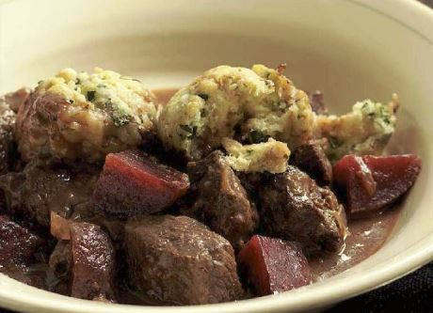  Beef and beetroot casserole | Pot roasting | Braising | Roasting
Grilling | Shallow frying | Barbequing | Microwave

