Mince fact sheet

- Beef, lamb and pork mince are made up of selected cuts which are then passed through a mincing machine.

- Beef and lamb mince contribute to a balanced diet and provide important nutrients for overall health and well-being. They are an important source of absorbable haem iron, B vitamins, zinc, protein and vitamin D.
- Pork mince typically contains less than 5% fat. It is low in sodium and high in selenium which defends against oxidative stress and regulates the thyroid. It is also good source of B vitamins, phosphorous and zinc.

What to look out for when buying mince

- Mince should be moist, rich and bright in colour, not pale or pink. Avoid mince that looks dry and dark brown as this may be nearing the end of its shelf life.

- Supermarket beef mince is available with a fat content of 5%, 10%, 12% and 20%.

- Pork mince is versatile and can be used on its own or combined with beef mince in many recipes including meatballs, burgers and meatloaf.

- Check the label for the fat content and ‘use-by’ date.

- Store mince in its original packaging in the coldest part of the refrigerator where it will keep for 1-2 days.

- Mince may be frozen for 3-4 months, but wrap in heavy-duty aluminium foil for protection from freezer burn.

- Defrost mince overnight in a plastic food container on the bottom shelf of a refrigerator. Use as soon as possible after defrosting.

Tips on cooking mince

- To prevent bacterial cross contamination, wash your hands, work surfaces and utensils with hot soapy water before and after handling raw mince.

Beef and lamb mince cooking tips
- For a main meal allow 100g of raw mince per person.

- The secret to cooking beef, lamb and pork mince is to use a very hot frying pan, which adds a rich, caramelised taste and deep colour to your dish.

- Either ‘dry fry’ or fry with oil (1 x 5ml spoon for every 450g) in a pre-heated hot heavy-based frying pan – not a saucepan! Alternatively, use a low calorie spray oil.

- If heat is insufficient, beef, lamb or pork mince will stew and the rich meat juices will leach out, leaving the meat grey and unappetising.

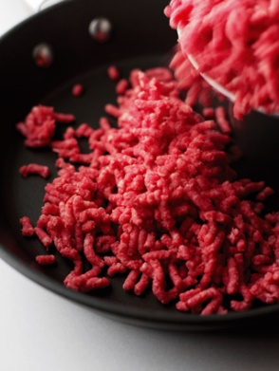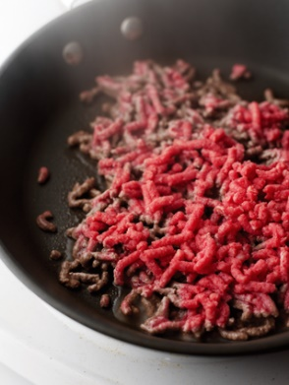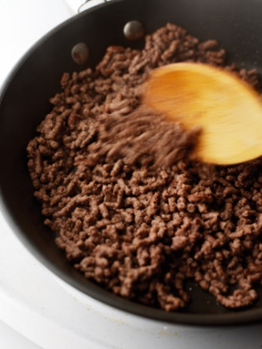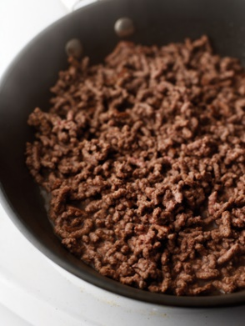

Ensure that the mince is browned thoroughly

- Leave pan uncovered so steam can escape to avoid ‘stewing’. Brown thoroughly until juices run clear. Then stir and break up large clumps of meat, draining off any excess fat from the pan before continuing with your recipe.

- Always look out for quality assured beef, lamb and pork.

- When shopping for beef, lamb or pork in the supermarket, look out for the quality logo on pack. The Red Tractor mark on quality beef and lamb guarantees that the meat is responsibly produced by people dedicated to producing great food.

- Each farmer and producer in the scheme is independently checked to ensure they meet strict standards. The flag in the logo represents the origin of the meat, so if it’s the Union flag you are guaranteed that the beef or lamb has been farmed and packed in the UK and is traceable back to the farms it came from.

- If you are exploring your local independent butcher you will find a Quality Standard label, rather than the Red Tractor logo.

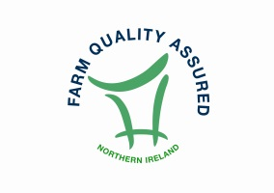



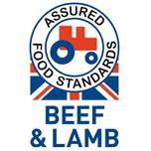
How to store and handle beef and lamb mince
