Food hygiene and safety when
making a red meat recipe

- Complete the table below stating where you would store the ingredients for a lamb tagine.

Ingredients | Where would you store the ingredients?
½ onion
50g (2oz) dried apricots
1x 15ml spoon (1tbsp) fresh coriander
225g (8oz) lean lamb mince
1x 5ml spoon (1tsp) ground paprika
1x 5ml spoon (1tsp) ground coriander
1x 5ml spoon (1tsp) ground ginger
1x 5ml spoon (1tsp) ground turmeric
200g canned chopped tomatoes
200g canned chickpeas

Equipment
Knife, chopping board, weighing scales, measuring spoons, can opener, large non-stick pan, mixing spoon and colander.

Method
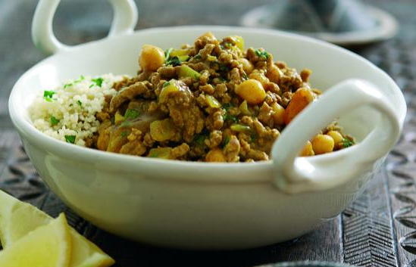
1. Prepare the ingredients:
- peel and finely chop the onion;
- cut the apricots into quarters;
- roughly chop the fresh coriander.
2. Dry-fry the lamb mince, onion, paprika, coriander, ginger, and turmeric for 3-4 minutes.
3. Stir in the chopped tomatoes.
4. Bring the mixture to the boil, reduce the heat and then simmer for 15-20 minutes.
5. Drain the canned chickpeas.
6. During the last 5 minutes, add the dried
apricots and chickpeas.
7. Stir in the fresh coriander and serve.

3. Describe how to be safe and hygienic before cooking the lamb tagine.
______________________________________________________________________

______________________________________________________________________

______________________________________________________________________

______________________________________________________________________

______________________________________________________________________

4. Describe how to be safe and hygienic during cooking the lamb tagine. ______________________________________________________________________

______________________________________________________________________

______________________________________________________________________

______________________________________________________________________

______________________________________________________________________

5. Describe how to be safe and hygienic after cooking the lamb tagine. ______________________________________________________________________

______________________________________________________________________

______________________________________________________________________

______________________________________________________________________

______________________________________________________________________

