What is red meat? Answers

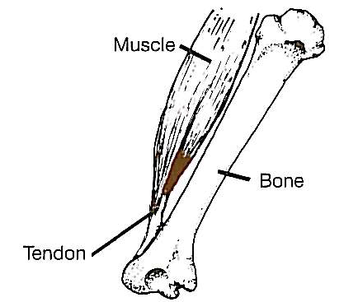
- Review the This is Meat presentation.

- Fill in the missing words.

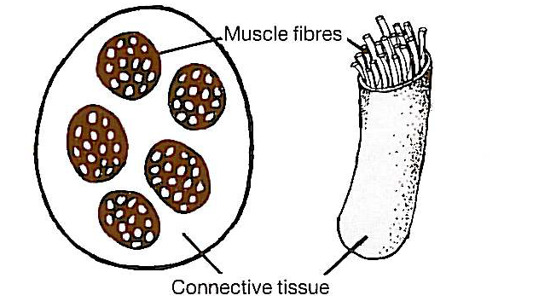
Raw meat is muscle with connective tissue, fat (adipose tissue) and tough white tissue/cartilage. The muscle is made up of bundles of muscle fibres called myofibrils bound together by connective tissue. Tendons join the muscle to the bones of animals.

The muscle fibres are very small thin tubes filled with water, mineral salts and muscle proteins. These are called myosin and actin.

Myosin and actin allow the muscle to contract (shorten) and create movement in live animals. When there is a lot of movement in the muscle, e.g. the leg the meat can be tough and will need longer slower cooking to make it tender.

Fine muscle fibres come from the muscles of young animals, or in older animals from the muscles which do least work. They contain little collagen and are tender even when cooking times short, e.g. grilling.

Meat has two main types of connective tissue, the proteins are called collagen and elastin. Collagen surrounds the fibre to make a bundle, wraps the bundles together and creates a thin covering over the muscle. When meat is cooked, the collagen becomes soft and soluble, and forms gelatine.

Elastin is much tougher and elastic even when cooked. The ligaments which join two bones together are mostly made up of elastin.

Fat is found under the skin and surrounds muscle tissue; this is often called visible fat. Fat is also contained in the muscle and is known as ‘marbling’.

The colour of meat is mainly due to a muscle cell pigment called myoglobin. Meats vary in colour; this is mainly due to the species and function of the particular muscle. Meat from muscles which have been used a lot and are from older animals is usually a darker colour.

When meat is stored the colour changes to a darker brown-red because of the formation of metmyoglobin. When meat is cut and exposed to oxygen in the air, it takes about twenty minutes for myoglobin to change to oxymyoglobin, which is brighter red in colour. After some time, the meat becomes a browner colour again as metmyoglobin is formed. These colour changes do not make any difference to the taste or texture.

