What is red meat?

- Review the This is meat presentation.

- Fill in the missing words.
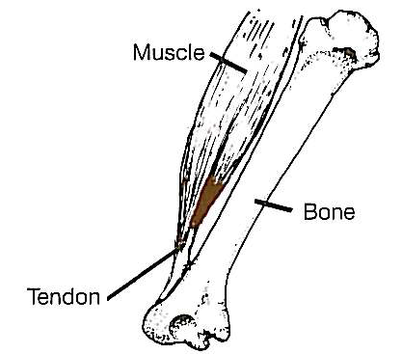
Raw meat is muscle with connective tissue, fat (adipose tissue) and tough white tissue/cartilage. The muscle is made up of bundles of muscle fibres called myofibrils bound together by connective tissue. …………….. join the muscle to the bones of animals.

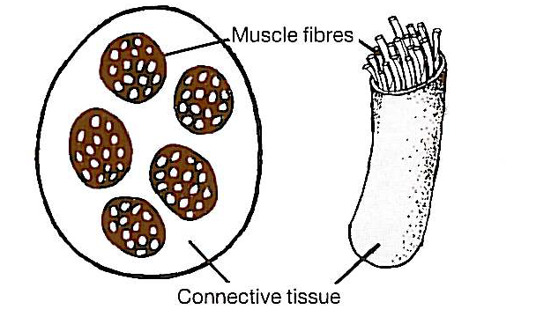
The muscle fibres are very small thin tubes filled with water, …………. salts and muscle proteins. These are called ………… and ………....

……….. and ………. allow the muscle to contract (shorten) and create movement in live animals. When there is a lot of movement in the muscle, e.g. the leg the meat can be tough and will need longer slower cooking to make it tender.

Fine muscle fibres come from the muscles of ………… animals, or in older animals from the muscles which do ……….. work. They contain little connective tissue and are tender even when cooking times are short, e.g. grilling.

Meat has two main types of connective tissue, the proteins are called ………….and ……….. Collagen surrounds the fibre to make a bundle, wraps the bundles together and creates a thin covering over the muscle. When meat is cooked, the collagen becomes soft and soluble, and forms ……………….

…………… is much tougher and elastic even when cooked. The ligaments which join two bones together are mostly made up of ………………..

Fat is found under the skin and surrounds muscle tissue; this is often called …………. fat. Fat is also contained in the muscle and is known as ……………...

The colour of meat is mainly due to a muscle cell pigment called ……………… Meats vary in colour; this is mainly due to the species and function of the particular muscle. Meat from muscles which have been used a lot and are from older animals is usually a …………. colour.

When meat is stored the colour changes to a darker brown-red because of the formation of …………………... When meat is cut and exposed to oxygen in the air, it takes about twenty minutes for ……………. to change to ………………….., which is brighter red in colour. After some time, the meat becomes a browner colour again as ………………. is formed. These colour changes do not make any difference to the taste or texture.

