Where does it come from?

The term food provenance means where your food has come from – where it is grown, raised or reared. Many consumers are interested to know about the provenance of their food for a variety of reasons:
- The consumer wishes to buy and consume food that is locally sourced because:
- it supports the local economy;
- it may be better quality as it has not travelled as far.
- Country of origin and traceability – the consumer knows where the food has come from.
- Sustainability - sourcing for some foods, e.g. tuna fish.
- Moral/ethical reasons, e.g. supporting farmers in other countries through a living wage.
- Environmental considerations, e.g. limited use of chemicals.
- Animal welfare.

Food assurance schemes
Assuring food safety and quality is a priority for the red meat industry. Consumers want to be reassured that what happens on the farm and in animal transport is professionally carried out using acceptable welfare, animal husbandry, healthcare standards and practices.

There are a number of schemes in the UK that provide information about meat for the consumer. Investigate the schemes listed below and complete the chart.

Food assurance scheme | What do they do?
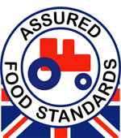 | Red Tractor
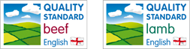 | English Beef and Lamb Assurance Schemes
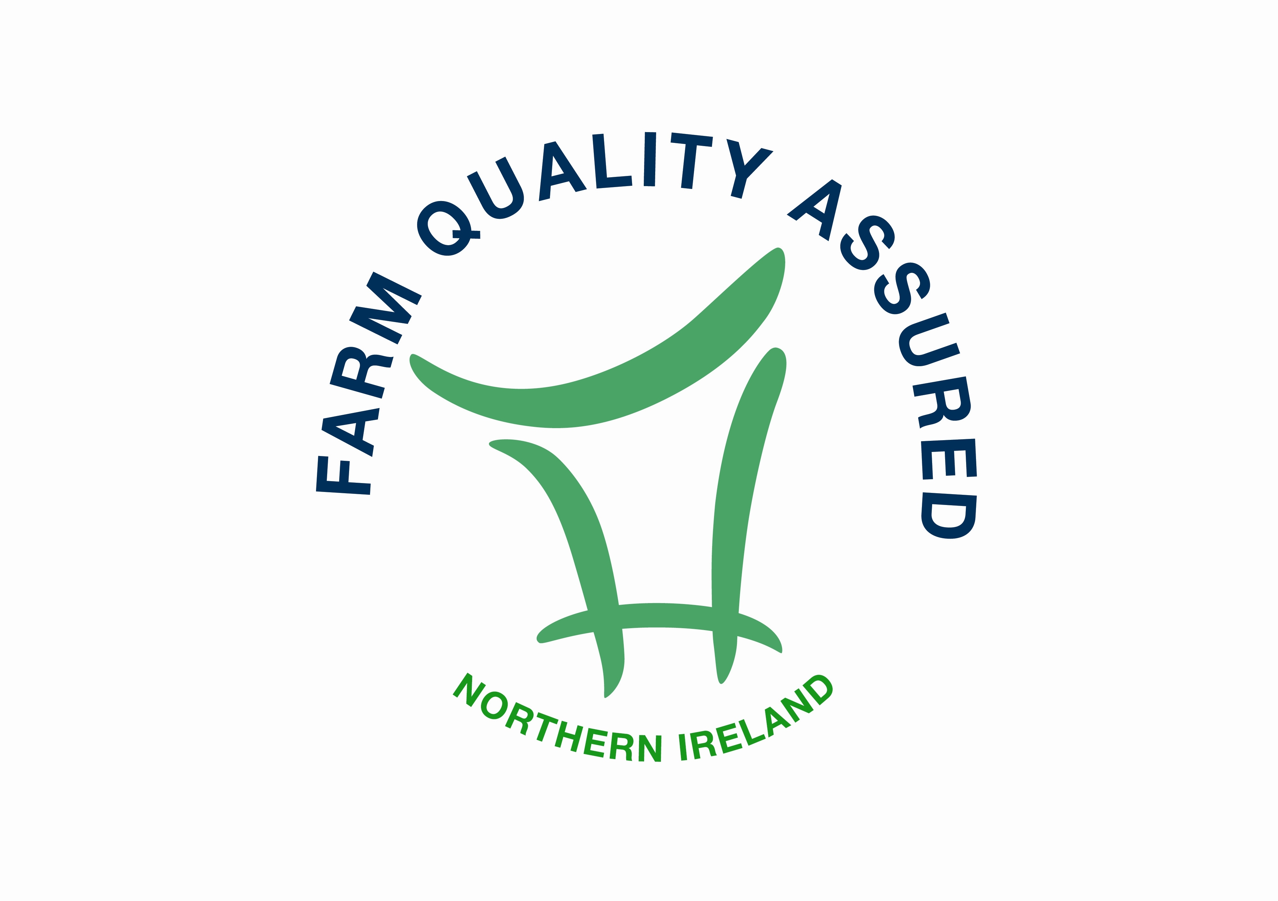 | The Northern Ireland Beef & Lamb Farm Quality Assurance Scheme
Welsh Lamb and Welsh Beef PGI  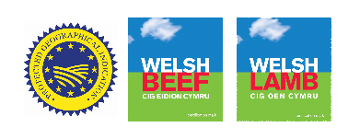  Scotch Beef and Scotch Lamb PGI  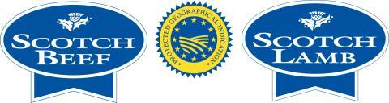  West Country PGI  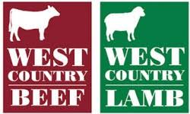 | Protected Geographical Indication (PGI)
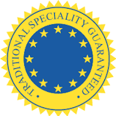 | Traditional Speciality Guaranteed (TSG)
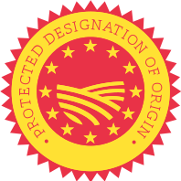 | Protected Designation of Origin (PDO)
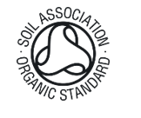 | Soil Association Organic Standard
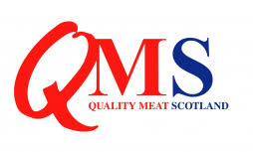 | QMS – Quality Meat Scotland
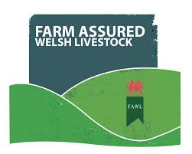 | Farm Assured Welsh Livestock

