Where does it come from? Answers

The term food provenance means where your food has come from – where it is grown, raised or reared. Many consumers are interested to know about the provenance of their food for a variety of reasons:
- The consumer wishes to buy and consume food that is locally sourced because:
- it supports the local economy;
- it may be better quality as it has not travelled as far.
- Country of origin and traceability – the consumer knows where the food has come from.
- Sustainability - sourcing for some foods, e.g. tuna fish.
- Moral/ethical reasons, e.g. supporting farmers in other countries through a living wage.
- Environmental considerations, e.g. limited use of chemicals.
- Animal welfare.

Food assurance schemes
Assuring food safety and quality is a priority for the red meat industry. Consumers want to be reassured that what happens on the farm and in animal transport is professionally carried out to high welfare, animal husbandry, healthcare standards and practices.

There are a number of schemes in the UK that provide information about meat for the consumer. Investigate the schemes listed below and complete the chart.

Food assurance scheme | What do they do?
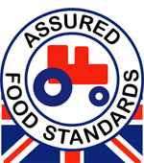 | Red Tractor  Red Tractor assurance standards for beef and lamb encompass food safety, animal welfare, environmental protection and traceability. The basic welfare needs of sheep and cattle must not be compromised at any stage of their lives and farmers must ensure that their farming practices do not damage the environment. Animals need to be identifiable and traceable back to their farms of origin and moved in clean vehicles so that the beef and lamb produced is free from contamination and safe to eat.
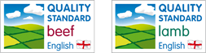 | English Beef and Lamb Assurance Schemes  The Quality Standard Mark Scheme for beef and lamb is an independent quality assurance for red meat in the United Kingdom.  Underpinned by the Red Tractor scheme, the standards contain combined guarantees of food safety, animal welfare and care for the environment with additional requirements also providing a guarantee of consistent eating quality.
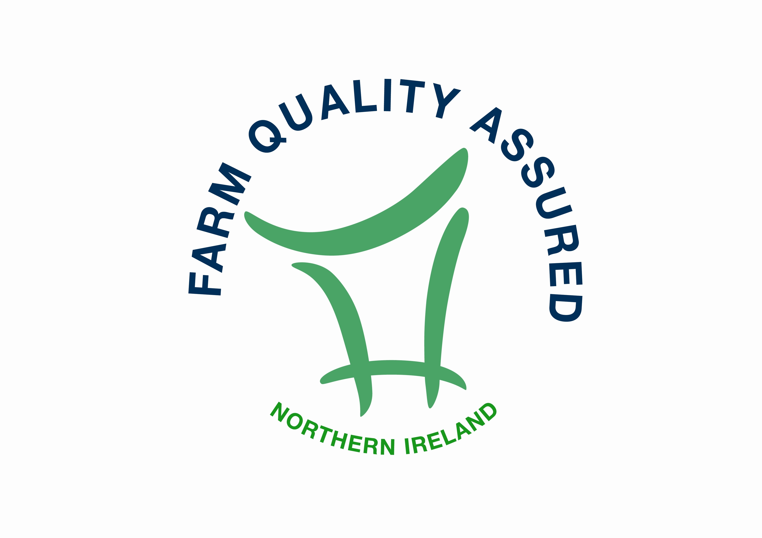 | Northern Ireland Beef and Lamb Farm Quality  The Northern Ireland Beef & Lamb Farm Quality Assurance Scheme was developed to give consumers assurances about the farm end of the production chain of their food.  It is about farm quality – the quality of the production methods used, the quality of care for animals which is practiced, the quality of the farm environment, and above all the quality of concern for the customer in producing beef and lamb which is wholesome, safe and free from unnatural substances.
Welsh Lamb and Welsh Beef PGI  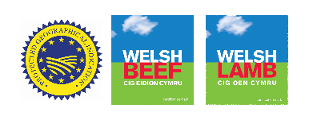  Scotch Beef and Scotch Lamb PGI  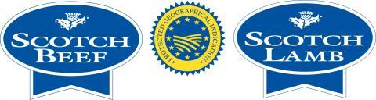  West Country PGI  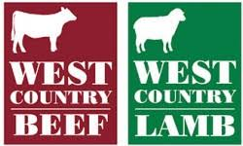 | Protected Geographical Indication (PGI)  PGI emphasises the relationship between the specific geographic region and the name of the product, where a particular quality, reputation or other characteristic is essentially attributable to its geographical origin.  For most products, at least one of the stages of production, processing or preparation takes place in the region.  PGI protects the product from other regions creating imitations.
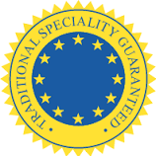 | Traditional Speciality Guaranteed (TSG)  Traditional speciality guaranteed (TSG) highlights the traditional aspects such as the way the product is made or its composition, without being linked to a specific geographical area. The name of a product being registered as a TSG protects it against falsification and misuse.
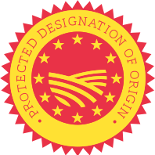 | Protected Designation of Origin (PDO)  Product names registered as PDO are those that have the strongest links to the place in which they are made. Every part of the production, processing and preparation process must take place in the specific region.
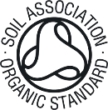 | Soil Association Organic Standard  The Soil Association Certification Limited is the UK’s largest and oldest certification body, licensing over 70% of the organic food on sale in the UK. For a food product to be labelled as organic, the supply chain has to meet organic standards and prove it to an organic certification body.
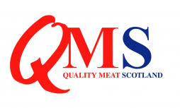 | QMS – Quality Meat Scotland  QMS is the public body responsible for helping the Scottish red meat sector improve its efficiency and profitability, and maximise its contribution to Scotland's economy.  The QMS assurance scheme covers more than 90% of livestock farmed for red meat in Scotland. They offer consumers in the UK and overseas the legal guarantee that the meat they buy has come from animals that have spent their whole lives being raised in Scotland.
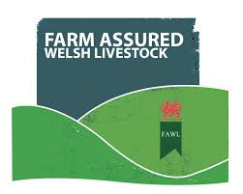 | Farm Assured Welsh Livestock  Welsh Lamb and Beef Producers Ltd. (WLBP) is a cooperative owned by over 7200 Welsh farmers. WLBP strives to strengthen consumer confidence by providing assurance of farm standards through the Farm Assured Welsh Livestock Beef and Lamb Scheme (FAWL).

FAWL and QMS have an earned recognition so these products can also carry a Red Tractor without any further auditing requirement.

