Have breakfast!
For a week, record what you eat and drink for breakfast.
What changes could be made to make these breakfasts healthier?

 | Food | Drink | Healthier changes
Example | White toast with jam | Whole milk | Wholegrain toast with peanut butter and semi-skimmed milk
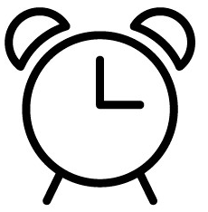
Monday

Tuesday

Wednesday

Thursday

Friday

Saturday

Sunday

