Drink plenty chart

Keep a record of the number of drinks you have each day, e.g. cups/glasses.

You can colour in or tick the water droplet for each drink you have in a day.

Monday | 💧 | 💧 | 💧 | 💧 | 💧 | 💧 | 💧 | 💧
Tuesday | 💧 | 💧 | 💧 | 💧 | 💧 | 💧 | 💧 | 💧
Wednesday | 💧 | 💧 | 💧 | 💧 | 💧 | 💧 | 💧 | 💧
Thursday | 💧 | 💧 | 💧 | 💧 | 💧 | 💧 | 💧 | 💧
Friday | 💧 | 💧 | 💧 | 💧 | 💧 | 💧 | 💧 | 💧
Saturday | 💧 | 💧 | 💧 | 💧 | 💧 | 💧 | 💧 | 💧
Sunday | 💧 | 💧 | 💧 | 💧 | 💧 | 💧 | 💧 | 💧
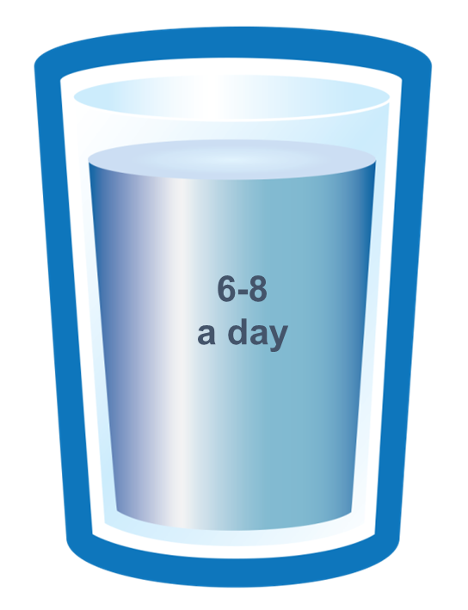

Aim to have at least 6-8 drinks every day.

