Healthy lunchbox builder

Use this template to build a healthy lunchbox!

Write or draw the food and drink that you are going to include in the lunchbox.

- Starchy carbohydrates, e.g. potatoes, bread, rice and pasta - choose wholegrain or higher fibre versions when possible!

- Plenty of fruit and vegetables – aim for a variety!

- A portion of beans, pulses, fish, eggs, meat and other proteins.

- A dairy food or calcium fortified dairy alternative.

- A drink, e.g. water semi-skimmed milk or 1% milk.

- A small amount of unsaturated oils and spreads (if included).
A healthy, balanced lunchbox should include:

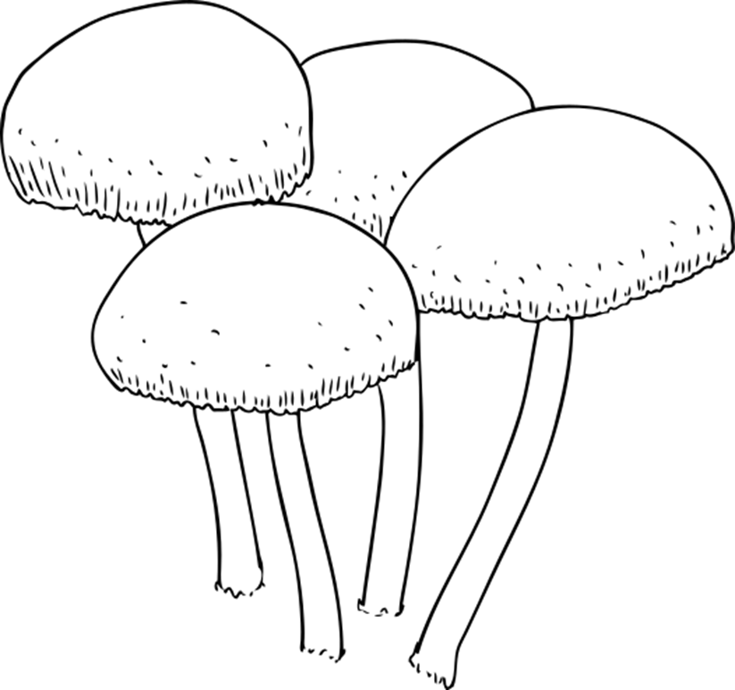
Drink
Main item
Extra fruit and vegetables
Dairy food
/dairy-alternative
(if not included in main item)

