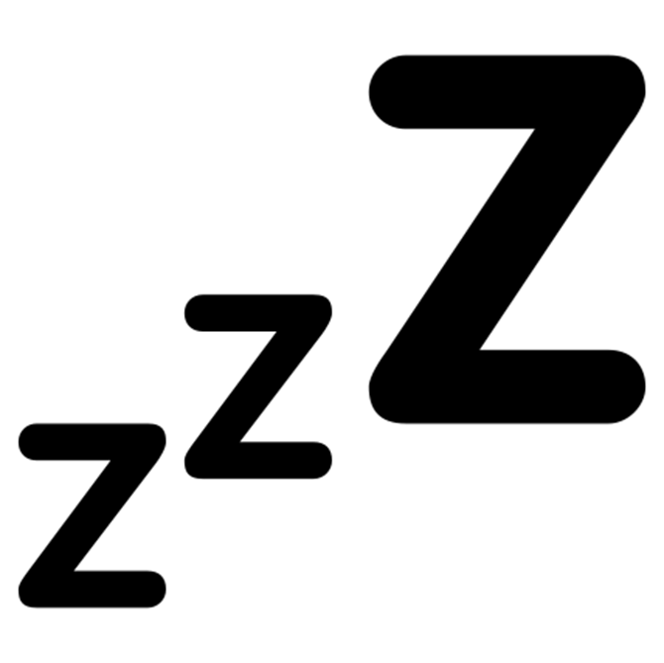

Sleep well diary
Complete the chart below.

 | Monday | Tuesday | Wednesday | Thursday | Friday | Saturday | Sunday
What time did you go to bed?

What time did you wake up?

What time did you fall asleep?

How many hours of sleep did you get?
How did you feel when you woke up?*

*For example, very tired, very awake, refreshed, happy, OK, etc.

