Red meat under the microscope

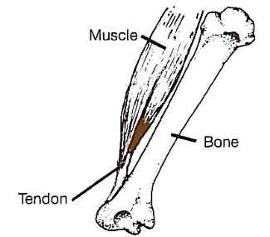
Fact: Meat is made up of muscle tissue or fibres (protein), connective tissue, fat and water.

Fact: Muscle is made up of bundles of muscle fibres. Muscle fibres are very small tubes filled with water and contain dissolved muscle proteins called myosin and actin.

Fact: Myosin and actin contract (shorten) the muscle to create movement in the animal. When there is a lot of movement in the muscles, the meat can be tough and will need longer cooking time to make it tender.

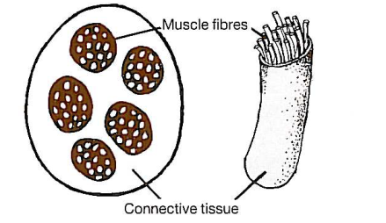
Fact: Meat has different types of connective tissue. Collagen surrounds the muscle’s fibres to make a bundle; it wraps the bundles together and makes a thin layer covering the muscle.

Fact: Fat surrounds the muscle tissue and is also contained in the muscle; this is called marbling.

Fact: The red colour of meat is due to a pigment called myoglobin; different meats vary in colour.

Fact: The texture and taste of cooked meat depends on the amount of fat and water in the meat and the proteins found in the meat.

Fact: The tenderness of the meat depends on the amount and type of connective tissue, the thickness and length of the muscle fibres, how much fat is in the muscle.
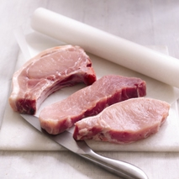
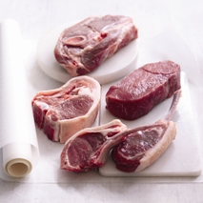
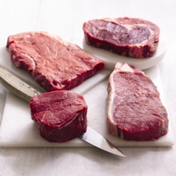
Beef
Lamb
Pork

