Cooking meat

- Describe the main reason for cooking meat.

- Explain why some cuts of meat need a longer cooking time than others,

- Complete the chart below showing the different methods that can be used for cooking meat.

Method
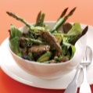
Frying

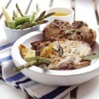
Grilling

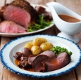  Roasting | Cooking food using dry, high temperatures in an oven. The dry heat caramelises the surface of the meat.
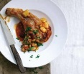
Braising
Stewing

Pot roasting

