Mexican meals

List the ingredients used to make these popular Mexican dishes.

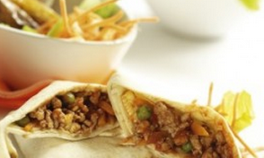
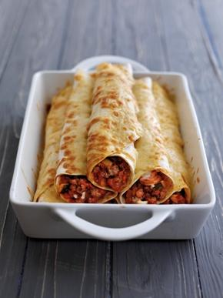
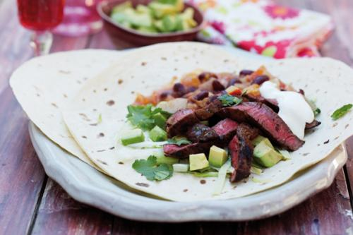
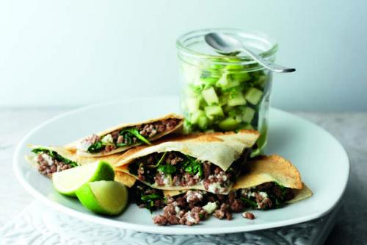
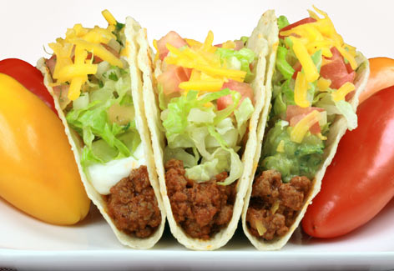

Burritos
Enchiladas

Fajitas

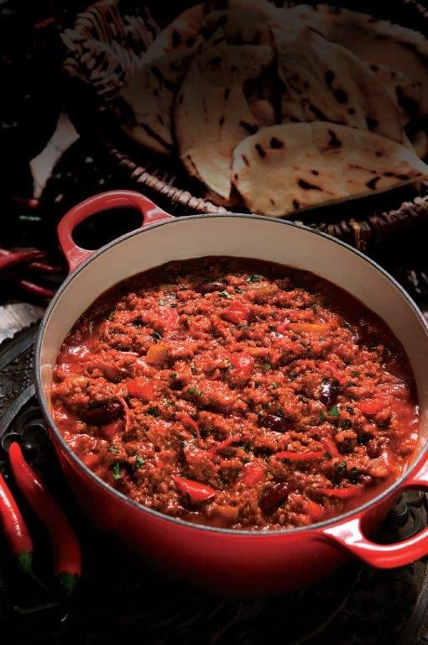

Chilli Con Carne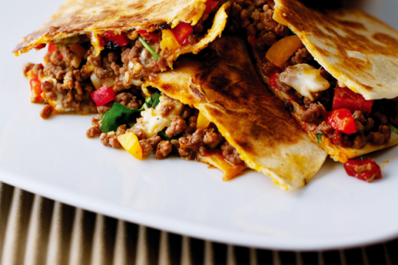
Quesadillas
Tacos

Chilli hot!

Mexican cuisine uses many different types of chillies. They have different characteristics (as well as levels of heat) making them suitable for a variety of dishes.

- What does the Scoville scale measure?

- What kind of chillies are chilli flakes and cayenne pepper made from?

- Explain how to prepare a chilli.

- Give examples of the following types of chilli peppers:

- Sweet and mild b. Medium

c. Hot d. Super-hot

