Multi-cultural cooking with beans

and pulses

Pulses include beans, lentils and peas. A pulse is an edible seed that grows in a pod and include all beans, peas and lentils, such as baked beans, chick peas, runner beans and many others.

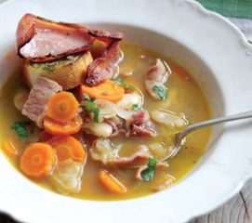
Pulses provide protein and iron; are versatile and can be used in many dishes such as casseroles, soups and sauces as well as being added to salads and eaten as an accompaniment. They are used in savoury and sweet dishes all over the world, examples include:

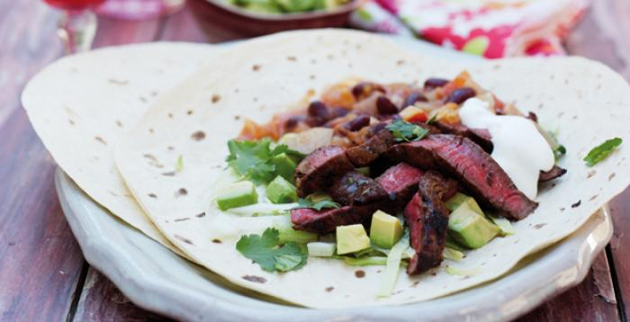
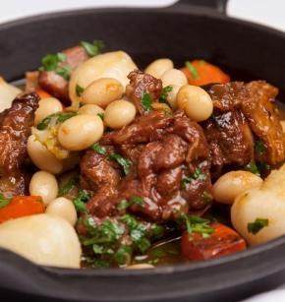

Task

Research three multi-cultural red meat dishes that include beans and pulses.

Explain what makes the recipes traditional to that country and/or culture; include an image of the recipe.
Recipe 1
Recipe 2
Recipe 3

