Sausage chilli cha cha cha - modifying a recipe

Ingredients

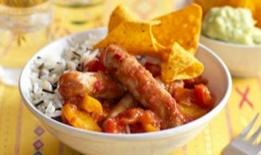
1 onion

1 red chilli or 1x 5ml spoon (1tsp) chilli flakes

1 orange or yellow pepper

1x 5ml spoon (1tsp) ground cumin

1x 15ml spoon (1tbsp) oil or spray oil

450g (1lb) pork chipolata sausages

400g can chopped tomatoes

400g can red kidney beans

1. What is meant by the term ‘modifying a recipe’?

2. Give four examples of how you can modify a basic recipe.

3. Explain how you would modify the Sausage Chilli Cha Cha Cha recipe for:

- Someone who does not like spicy food:

- A friend who is a vegetarian:

- A family member who has an intolerance to gluten:

