Tasty choices

Seasoning is used to enhance the flavour of food. It also helps to reduce or eliminate adding salt to recipes. Spices and herbs are used to season food and to give distinctive aromatic tastes and aromas. Complete the following table.

Herb / spice |  | Where does it come from? | Uses
Coriander | 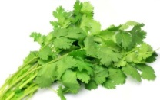
Turmeric | 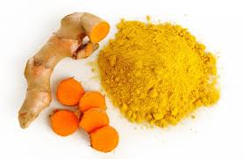
Bay leaves | 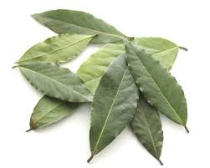
Cumin | 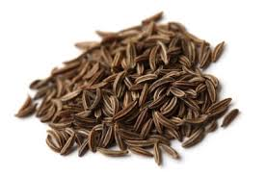
Paprika | 