What’s in season?

1. Explain the term ‘seasonal’.

2. Give four seasonal examples of fruit and vegetables from the UK.

SPRING | SUMMER | AUTUMN | WINTER

2. Read the ingredients list below.

This is a versatile recipe that could be modified to use a selection of seasonal ingredients. How could this recipe be modified? Record your ideas on the next page.

Lamb and vegetable crumble Serves: 6 Time to cook: 50-60 minutes

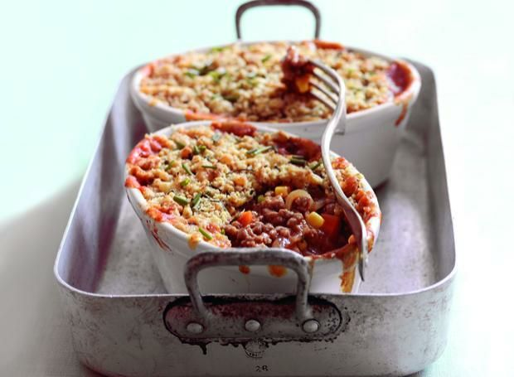
Ingredients

1 celery stick

2 medium onions

2 carrots

100g (4oz) hard cheese, e.g. Cheddar

1x 15ml spoon (1tbsp) chives

450g (1lb) lean lamb mince

1x 15ml spoon (1tbsp) dried rosemary

1 lamb stock cube

425ml (¾pt) water

2x 15ml spoon (2tbsp) flour

2x 15ml spoon (2tbsp) tomato purée

3x 15ml spoon (3tbsp) Worcestershire sauce

Black pepper

75g (3oz) wholemeal plain flour

75g (3oz) plain flour

75g (3oz) butter

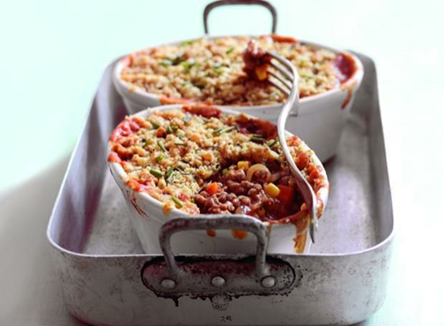

I could modify….
I could modify….
I could modify….
I could modify….

