Around the world
Pasta
Quinoa

Couscous
Bulgar wheat
Wild rice
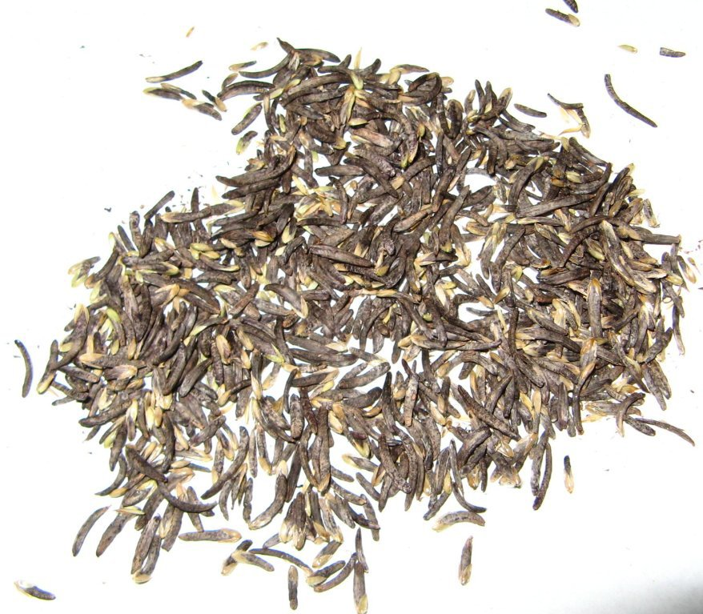

1. What cereal crop are these ingredients made from?

Bulgar wheat……………………………………… Couscous …………………………………………….

Wild rice……………………………………………

Quinoa …………………………………………… Pasta…………………………………………………….

2. Research how they are cooked and give two examples of dishes that are made using the ingredient.
Bulgar wheat recipes
Couscous recipes
Wild rice recipes
Quinoa recipes
Pasta recipes

