Beans and pulses

Find out more about the beans and pulses shown below.

Where do they come from? How are they cooked? What recipes are they used in?

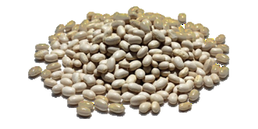
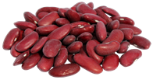
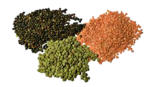
Haricot beans

Example recipes

Broad beans

Example recipes

Red kidney beans

Example recipes
Lentils

Example recipes

