Food safety

Bacterial growth

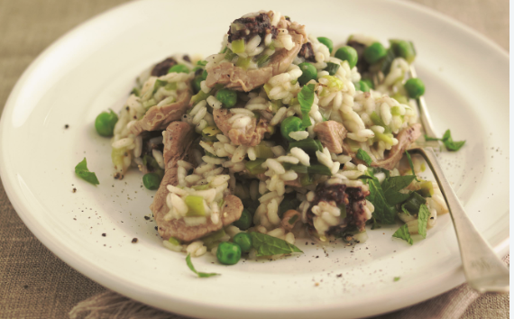
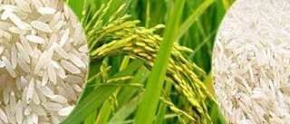

- What conditions are needed for bacteria to grow?

- Explain the temperature ‘danger zone’.

- What are high risk foods?

- Investigate the bacterium Bacillus cereus. Explain how the pork risotto should be stored and reheated if it is not going to be eaten straight away.

