Healthy eating

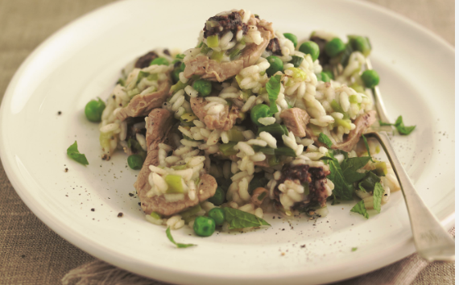
- Pork risotto is a composite dish; this means that it is made from more than one food group from The Eatwell Guide. List the main ingredients used and identify the food group for each.

- What changes could be made to the recipe to increase the fibre content or reduce the fat content? Suggest two example for each.

- Increase fibre:

- Reduce fat:

- Plan a two course meal that includes the pork risotto. Explain how you have reflected current healthy eating guidelines.

