Blazing burger

Ingredients
Complexity: medium
1 small red onion
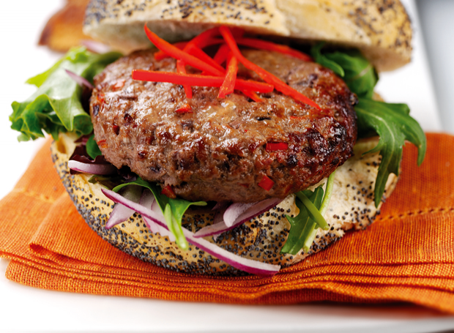
1cm piece fresh root ginger
1 red chilli
225g lean beef mince
1 x 5ml Worcestershire sauce

Equipment
Knife, chopping board, weighing scales, large bowl, measuring spoon, plate, cling film, fish slice, tongs, oven gloves.

Method
- Prepare the ingredients:
  - peel and finely chop the onion;
  - peel and finely chop the ginger;
  - deseed and chop the chilli.
- Place the beef mince, onion, ginger, chilli and Worcestershire sauce in a large mixing bowl.
- Mix the ingredients together.
- Divide the mixture into 2 evenly-sized portions with damp hands.
- Shape each portion into a round and gently flatten to a burger shape.
- Place the burgers on a clean plate, cover and chill in the refrigerator for up to 30 minutes, if time permits.
- Preheat the grill or prepare the barbeque.
- Cook the burgers for 6-8 minutes on each side, or until cooked through and any meat juices run clear.

Top tips
- If preferred replace the ginger with 1-2 x 15ml curry powder and the Worcestershire sauce with mango chutney.
- To prevent the burgers breaking up during cooking on the barbecue, place on a sheet of aluminium foil over the barbecue grill.
- Serve the burgers in rolls garnished with salad leaves, finely shredded chilli strips and a spoonful of your favourite prepared relishes and potato wedges.

Food skills
- Weigh.
- Measure.
- Peel.
- Chop.
- Mix.
- Portion and divide.
- Chill.
- Grill.

