Mini meatballs
Complexity: low-medium

Ingredients
225g lean beef mince
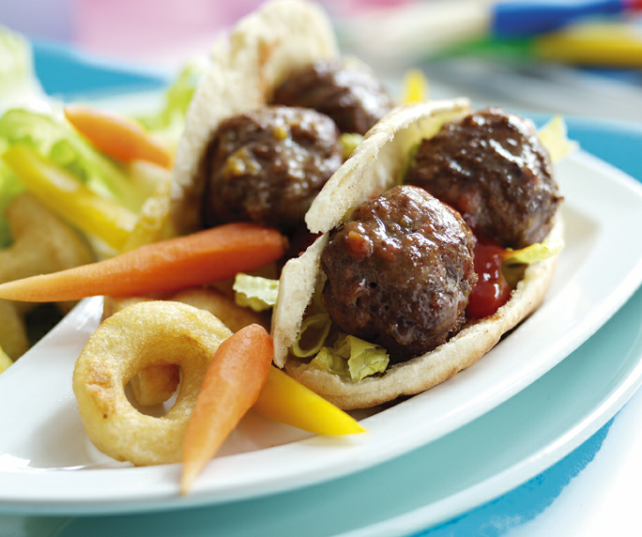
200g frozen mixed vegetables
15ml spoon tomato ketchup

Equipment
Weighing scales, microwave safe container, knife, chopping board, large mixing bowl, measuring spoon, baking tray, oven gloves.

Method
- Pre heat the oven to 180°C or Gas Mark 4.
- Cook the frozen vegetables in the microwave for 1-2 minutes in a microwave safe container.
- Allow the vegetables to cool a little and then chop them into small pieces
- Mix the lean beef mince, chopped vegetables and tomato ketchup together in a large mixing bowl.
- Shape the mixture into 24 meatballs.
- Place the meatballs on a baking tray.
- Cook in the oven for 10 minutes, until the juices run clear.

Top tips
- Serve in pitta bread with salad.
- Using lightly floured hands when shaping the meatballs will help if the mixture is a bit sticky.
- Try adding different spices or sauces for a different flavoured meatball.
- If time permits, chilling the meatballs before cooking will help them keep their shape.

Food skills
- Weigh.
- Measure.
- Microwave.
- Chop.
- Mix.
- Shape.
- Bake.

