Lamb celebration crackers
Complexity: Medium-High

Ingredients
1 onion
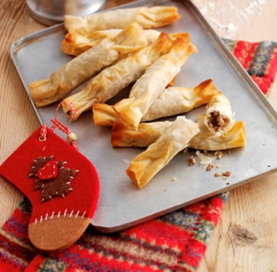
2 x 15ml spoon fresh mint
225g lean lamb mince
2 x 15ml spoon instant bulgur wheat
1 x 5ml spoon cumin
4 x 15ml water
Black pepper
12 sheets of filo pastry
2 x 15ml oil

Equipment
Baking tray, knife, chopping board, non-stick frying pan, mixing spoon, measuring spoon, small bowl, pastry brush, oven gloves.

Method
- Pre-heat the oven to 180˚C or Gas mark 4.
- Grease or line the baking tray.
- Prepare the ingredients:
  - peel and chop the onion;
  - chop the mint.
- Dry-fry the lamb mince and onion until brown.
- Stir in the bulgur wheat, cumin and water and cook for 5 minutes.
- Stir in the mint and black pepper and set aside to cool.
- Cut the filo pastry into rectangles, approximately 16 x 13 cm.
- Place two rectangular sheets together and brush edges with oil.
- Place two teaspoons of the filling into the middle of the pastry rectangle.
- Roll the filo pastry into a sausage shape and pinch the pastry at each end to create the frilly ends of the cracker.
- Repeat with the remaining pastry and filling.
- Place the crackers on a baking tray and lightly brush with oil.
- Bake for 10-15 minutes until the pastry is golden brown.

Top tips
- Try a different filling combination using pork or beef mince.
- Try adding small pieces of vegetables, such as grated carrot or courgette.
- These can be served hot or cold, as a starter or a snack.
- Cover unused sheets of filo pastry with cling film to prevent the pastry from drying out.
- Try making smaller crackers for canapés or a larger cracker for a buffet.

Food skills
- Weigh.
- Measure.
- Peel.
- Chop.
- Fry.
- Stir.
- Cut out.
- Layer.
- Form and shape.
- Glaze.

