Lamb curry with sweet potatoes
Complexity: Medium - High

Ingredients
1 small red onion
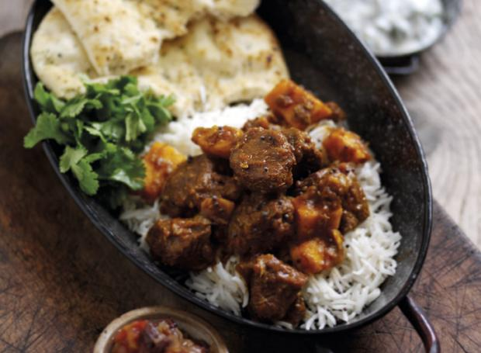
1 garlic clove
1 x 2.5cm fresh root ginger
2 green chillies
1 small sweet potato
½ lime
3 x15ml spoon fresh coriander
225g lamb shoulder
1 x 15ml oil
2 x 15ml spoon garam masala
1 x 5ml spoon ground turmeric
100ml water
1 lamb stock cube
1 x 400g canned chopped tomatoes
Black pepper

Equipment
Knife, chopping board, garlic crusher, measuring spoons, weighing scales, non-stick frying pan, can opener, mixing spoon, 1.2L heatproof casserole dish and lid, kettle, measuring jug, oven gloves.

Method
- Preheat the oven to 180˚C or Gas Mark 4.
- Prepare the ingredients:
  - peel and slice the onion;
  - peel and crush the garlic;
  - peel and finely chop the ginger;
  - deseed and finely chop the green chillies;
  - peel and cut the sweet potato into small cubes;
  - juice the lime;
  - roughly chop the coriander.
- Using a clean knife and chopping board, dice the lamb shoulder meat into 2.5cm cubes.
- Heat half the oil in a large non-stick pan and brown the lamb for 3-4 minutes.
- Spoon the lamb into the heatproof casserole dish.
- Add the remaining oil to the same pan and cook the onion, garlic, ginger, garam masala and turmeric for 3-4 minutes or until soft and golden.
- Spoon the mixture into the casserole dish.
- Make up the lamb stock.
- Add the tomatoes, lamb stock, chillies and black pepper.
- Bring to the boil, reduce the heat, cover with a lid and cook for 2-2½ hours or until the lamb is tender, stirring occasionally.
- 20 minutes before the end of the cooking time add the sweet potato and the lime juice.

Top tips
- Garnish with the coriander and black mustard seeds and serve with basmati rice, naan bread and a chutney of your choice.

Food skills
- Weigh.
- Measure.
- Peel.
- Crush.
- Slice, chop, dice and cut.
- Juice.
- Fry.
- Casserole.
- Combine.
- Boil and simmer.

