Lamb fajitas with yogurt
Complexity: Medium-High

Ingredients
¼ cucumber
8 spring onions
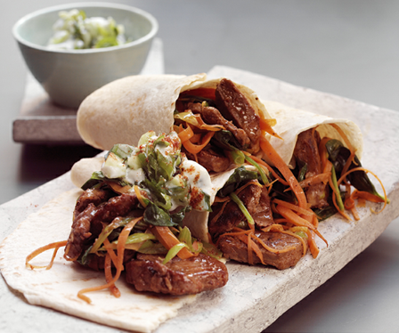
1 carrot
1 lemon
1 x 5ml spoon mint
120ml natural yogurt
¼ x 5ml spoon chilli powder
225g lean lamb neck fillet or lamb leg steaks
2 x 5ml spoon Fajita seasoning
100g baby spinach leaves
4 x flour tortillas

Equipment
2 x knives, 2 x chopping boards, measuring jug, grater, zester, peeler, measuring spoons, small mixing bowl, non-stick frying pan or wok, mixing spoon, serving plates.

Method
- Prepare the ingredients:
  - slice the cucumber;
  - finely slice 2 spring onions;
  - roughly chop 6 spring onions;
  - peel and grate the carrot;
  - zest and juice the lemon;
  - roughly chop the mint.
- Mix the natural yogurt, cucumber, finely chopped spring onions, cucumber, chilli powder and fresh mint in a bowl and set aside.
- Using a clean knife and chopping board cut the lamb neck fillet or leg steaks into thin strips.
- Dry fry the lamb strips in a non-stick frying pan or wok for 5-6 minutes.
- Add the fajita seasoning and cook for a further 1-2 minutes.
- Add the carrot, roughly chopped spring onions, lemon zest and juice.
- Remove from the heat and stir in the baby spinach leaves.
- Divide the mixture evenly between the 4 flour tortillas.
- Place a spoonful of yogurt mixture on top before rolling up the flour tortillas.

Top tips
- These can be served with a large pile of mixed salad leaves.

Food skills
- Weigh.
- Measure.
- Slice, cut and chop.
- Peel.
- Grate.
- Zest.
- Juice.
- Mix and stir.
- Fry.
- Divide and portion.
- Shape.

.

