Meaty marrow rounds
Complexity: Medium-High

Ingredients
450g potatoes
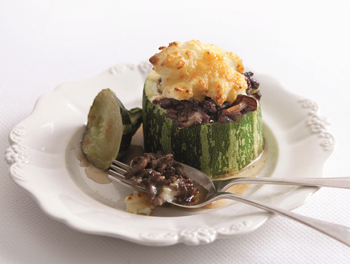
1 onion
4 mushrooms
1 marrow
50g hard cheese, e.g. Cheddar
450g lean minced beef
1 beef stock cube
300ml water
1 x15ml spoon gravy granules
3 x 15 ml spoon milk

Equipment
Weighing scales, knife, chopping board, peeler, grater, large saucepan, non-stick frying pan, mixing spoon, kettle, measuring jug, measuring spoon, colander, potato masher, baking tray, spoon, oven gloves.

Method
- Preheat oven to 180°C or Gas Mark 4.
- Prepare the ingredients:
  - peel and chop the potatoes into chunks;
  - peel and chop the onion;
  - slice the mushrooms;
  - cut the marrows into thick rings;
  - grate the cheese.
- Place the potatoes in a large saucepan and cover with water.
- Bring to the boil, then reduce the heat and simmer for 15-20 minutes until soft.
- Dry-fry the beef mince and onions until browned.
- Make up the stock.
- Add the beef stock, mushrooms and gravy granules to the meat mixture and bring the mixture to the boil.
- Stir the mixture well, reduce the heat and allow the mixture to thicken.
- Drain the potatoes and mash with the milk.
- Place the marrow rings onto a baking tray and fill with the meat sauce.
- Spoon the mashed potato on top and sprinkle with a little grated cheese.
- Cook in the oven for 25-30 minutes, until golden brown.

Top tips
- If you prefer a spicy dish, add 15ml (1tbsp) curry powder or chilli powder as you brown the mince.

Food skills
- Weigh.
- Measure.
- Peel.
- Chop, slice and cut.
- Grate.
- Boil and simmer.
- Fry.
- Mix and stir.
- Drain.
- Bake.

