Pork, apple and cheese wheels
Complexity: Medium-High

Ingredients
1 onion
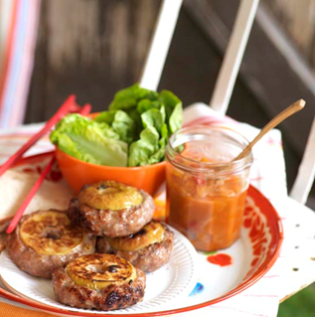
1 large apple, e.g. Cox
50g hard cheese, e.g. Cheddar
1 x 5ml spoon oil
450g lean pork mince
1 x 15ml spoon apple sauce
Black pepper

Equipment
Knife, chopping board, measuring spoon, frying pan, mixing spoon, large bowl, plate, cling film, tongs, oven gloves.

Method
- Prepare the ingredients:
  - peel and chop the onion finely;
  - core and slice the apple into 5 slices;
  - cut the cheese into small pieces.
- Heat the oil in a small frying pan, cook the onion until soft and then set aside.
- Place the pork mince, apple sauce, cheese cubes, onion and a few twists of black pepper in a large bowl.
- Mix until well combined.
- Divide the mixture into 5 equal portions.
- Shape each portion into a ball and then press an apple slice into the top, leaving the surface of the apple exposed.
- Place the patties on a clean plate and cover with cling film and chill in the refrigerator for up to 30 minutes, if time allows.
- Pre-heat the grill.
- Cook the patties for 15 minutes, turning these once during cooking.

Top tips
- The pork, apple and cheese wheels can be served with crusty, chunky bread slices, salad leaves and barbecue sauce.
- When cooking, if the outside of the patties begin to burn before the meat is cooked through, either turn down the grill or cover with foil and lower the height of the grill pan away from the heat source.

Food skills
- Weigh.
- Measure.
- Peel.
- Chop, slice and cut.
- Fry.
- Mix and combine.
- Divide and portion.
- Shape.
- Chill.
- Grill.

